

# CLOUD COMPUTING LAB

**BSE ( V-B )**

Submitted By:

Musfira Farooq

Roll No:

2023-BSE-045

Submitted To:

Sir Muhammad Shoaib

**LAB 14(openended lab)**

**Terraform + Ansible: Dynamic Inventory, Roles & Automated Nginx/PHP & Docker Deployment**

**Task 0 – Lab Setup (Codespace & GH CLI)**

Codespace successfully launched

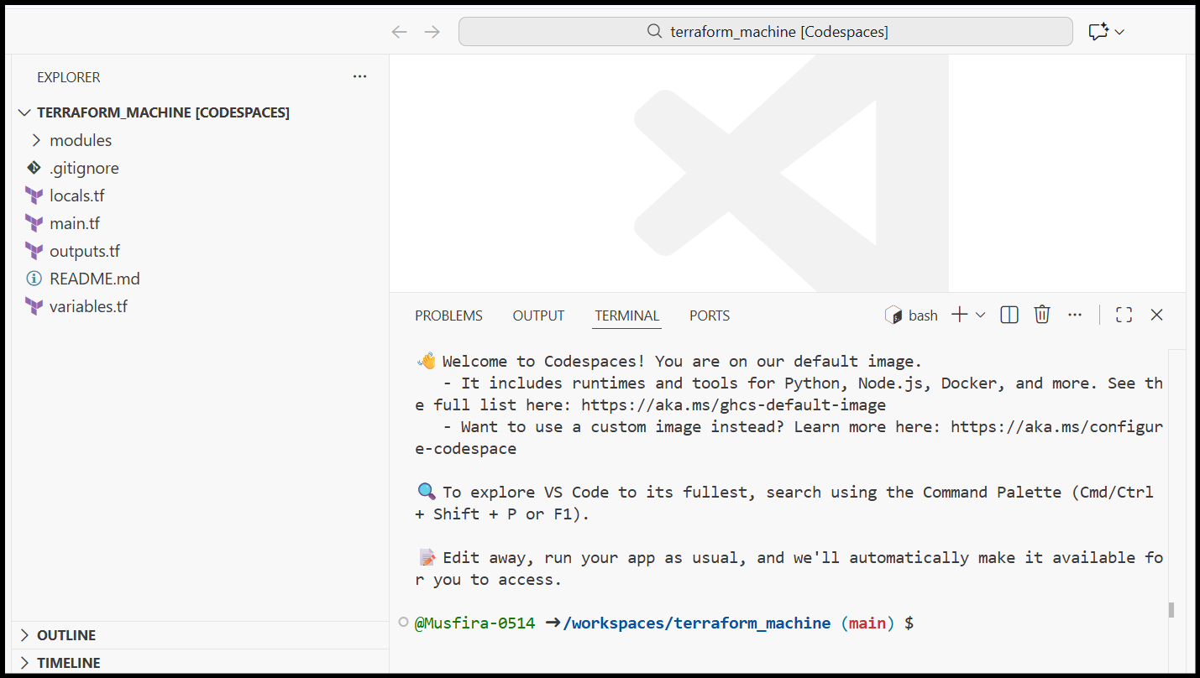

Environment verification inside Codespace

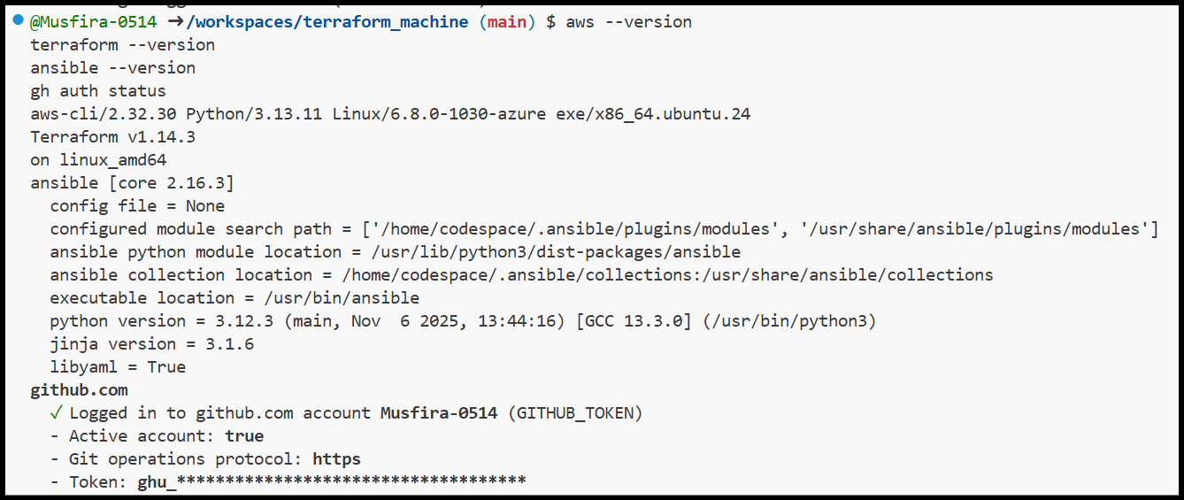

AWS CLI configured inside Codespace

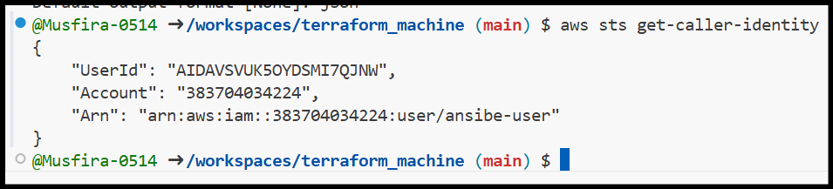

**Task 1 – SSH Key Generation & Initial Terraform Apply**

SSH key status before generation

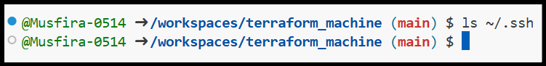

SSH key generation command execution

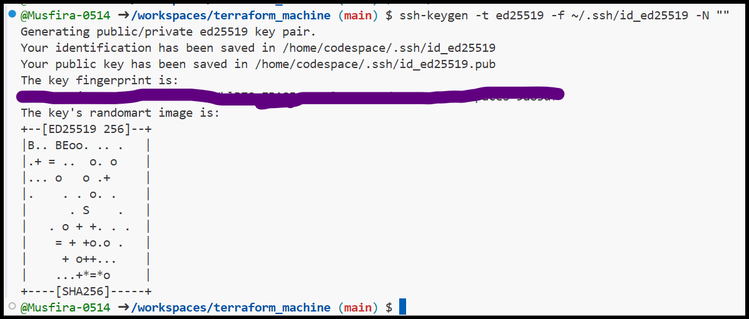

SSH key successfully created

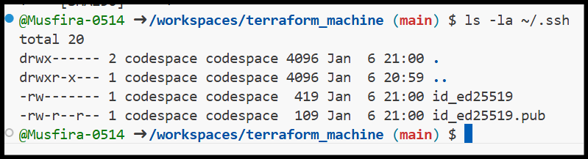

Terraform variables file created

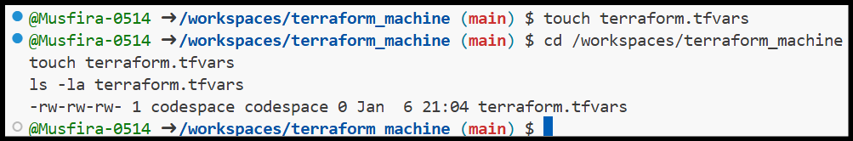

Terraform variables configuration

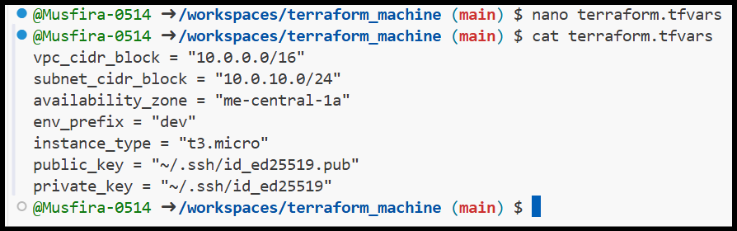

Terraform initialization

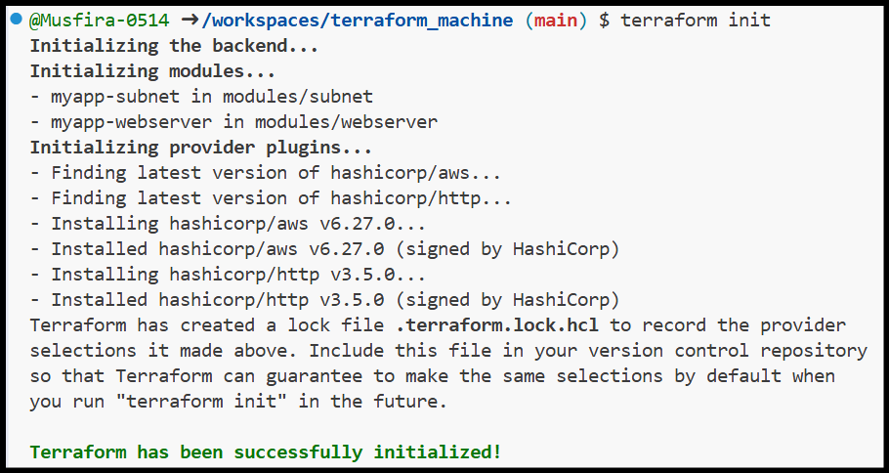

Terraform apply creating two EC2 instances

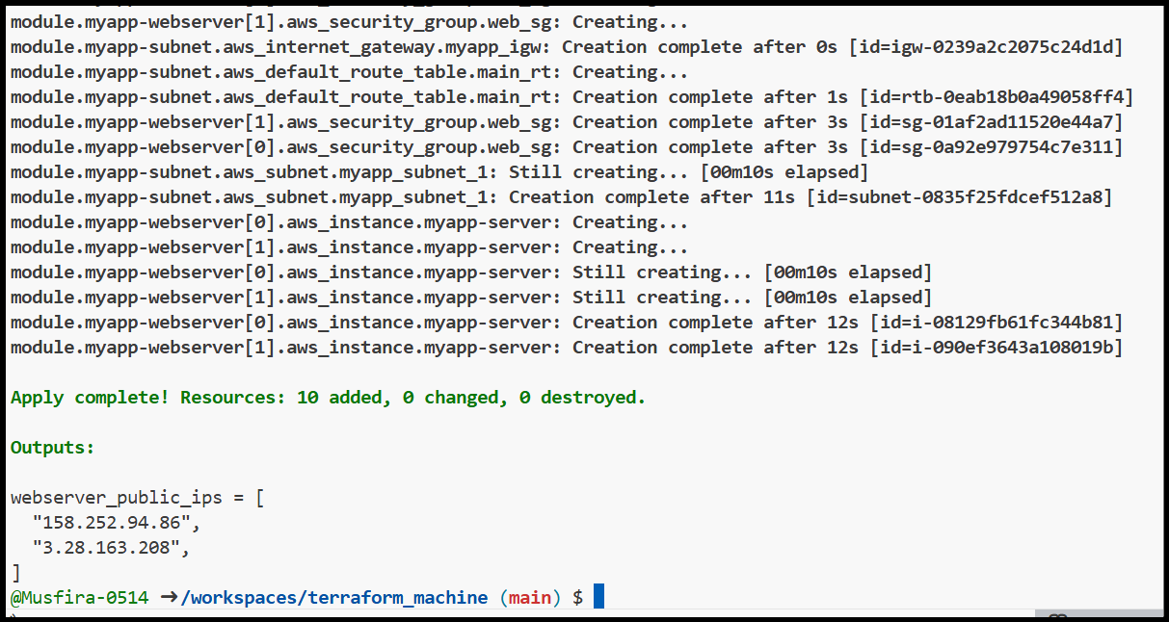

Terraform outputs showing public IPs

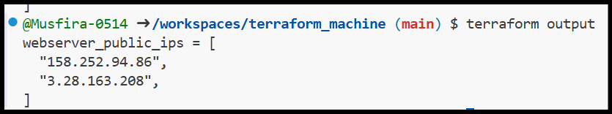

**Task 2 – Static Ansible Inventory Configuration**

Ansible installation verification

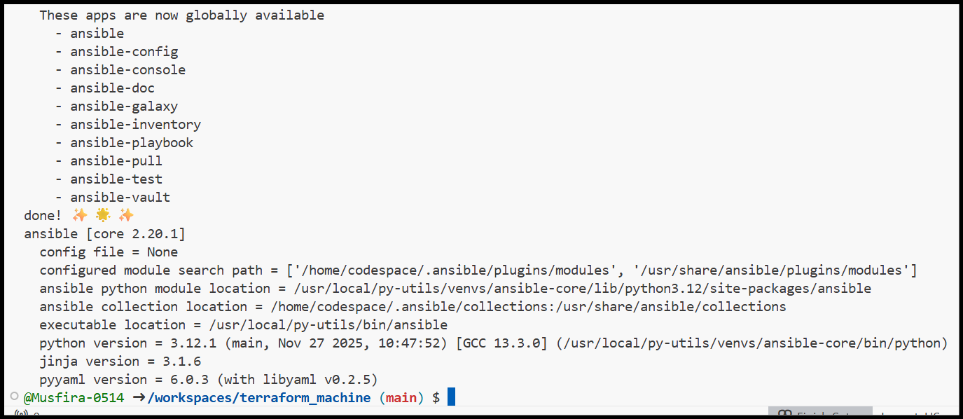

Terraform output used for inventory

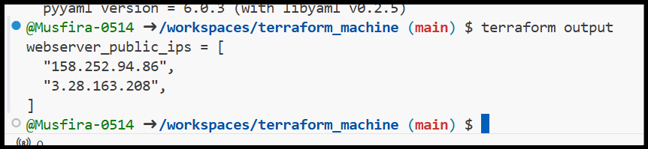

Initial Ansible hosts file created

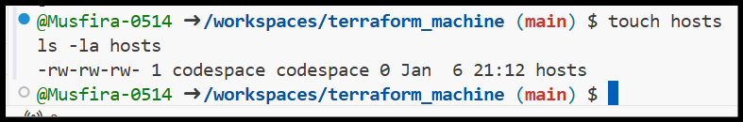

Hosts file before adding SSH arguments

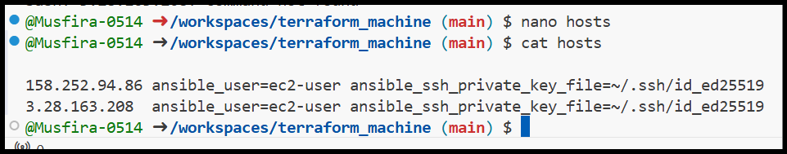

Ansible ping failure due to missing SSH args

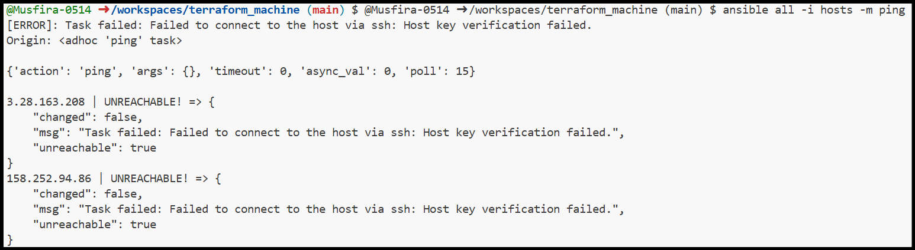

Hosts file updated with common SSH arguments

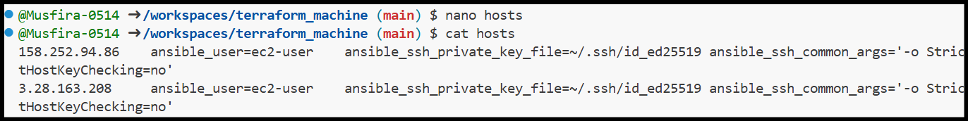

Successful Ansible ping to EC2 instances

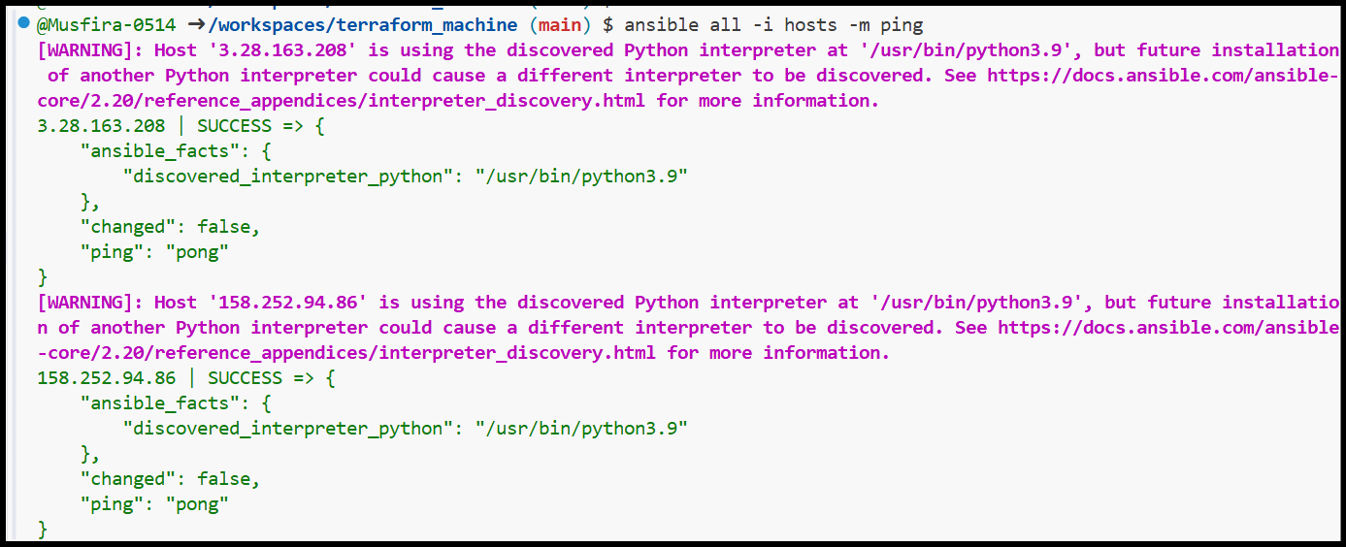

**Task 3 – Scaling Infrastructure to Three Instances**

Terraform updated to launch three instances

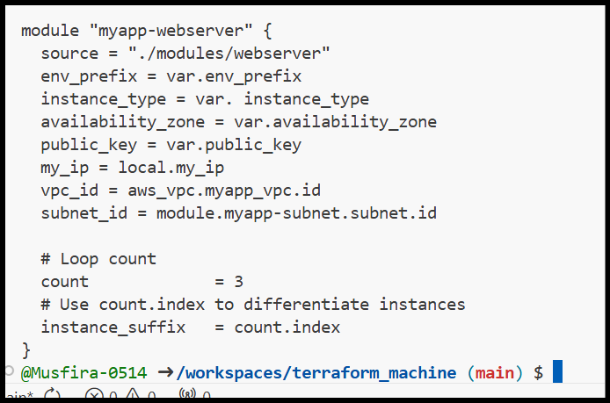

Terraform apply showing three instances created

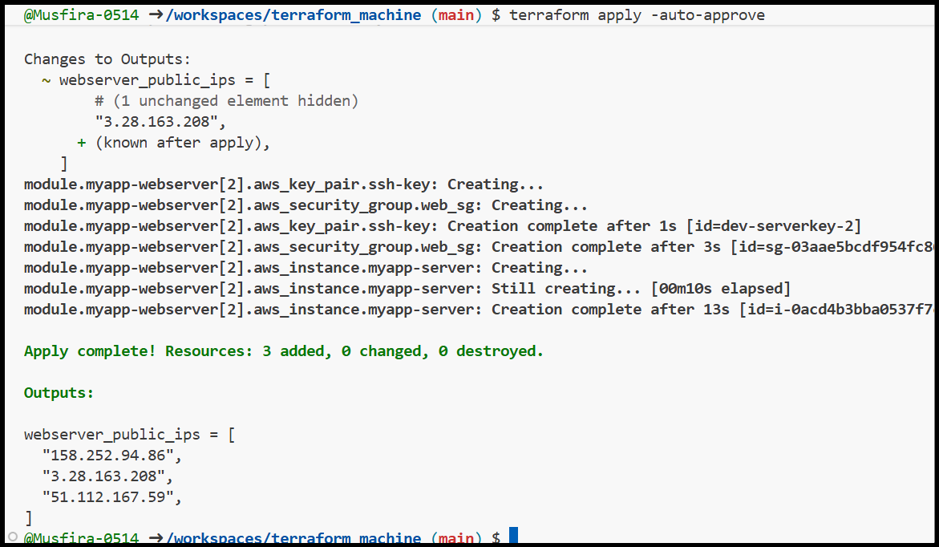

Terraform output displaying three IPs

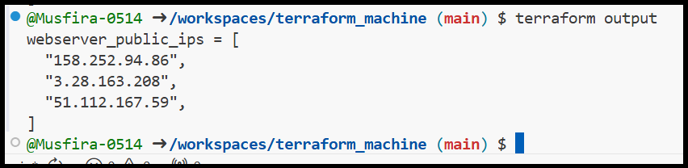

Inventory grouped into EC2 and droplet hosts

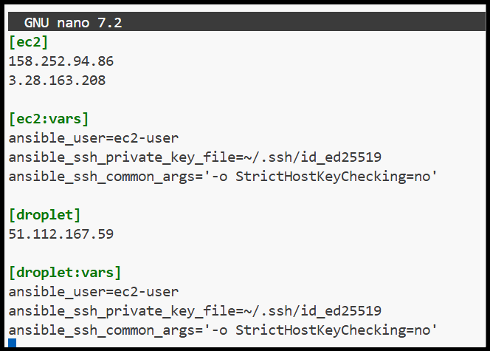

Ansible ping to EC2 group

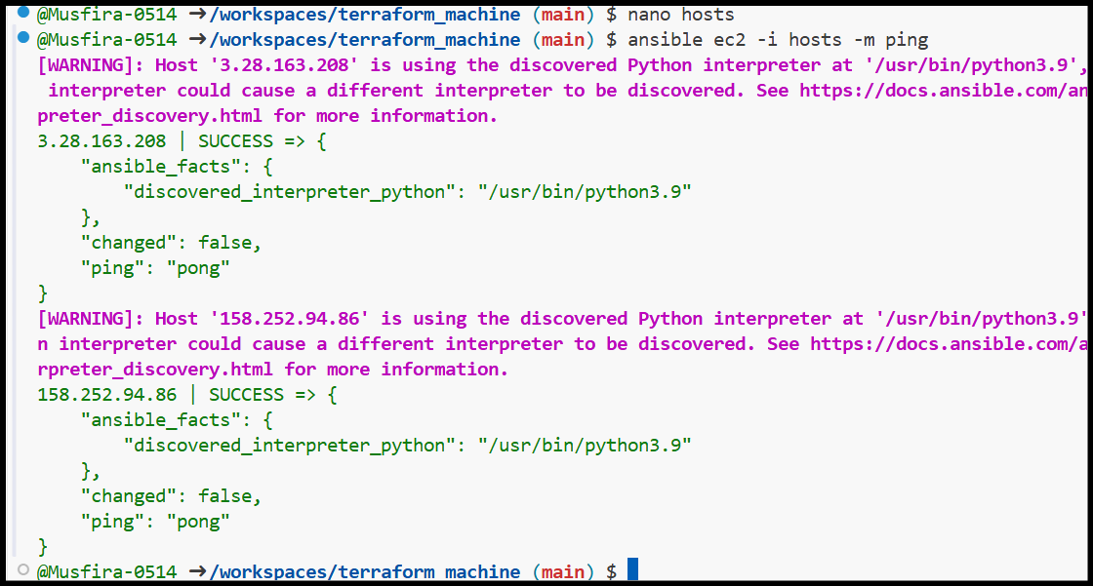

Ansible ping to single EC2 IP

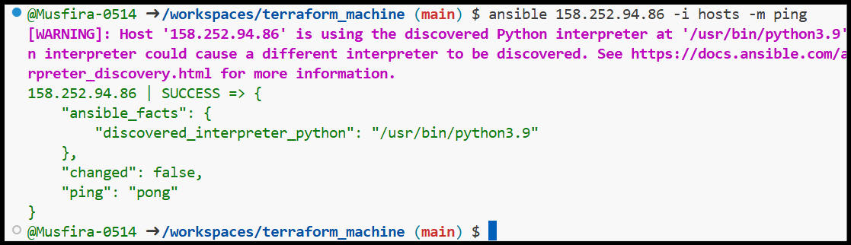

Ansible ping to droplet group

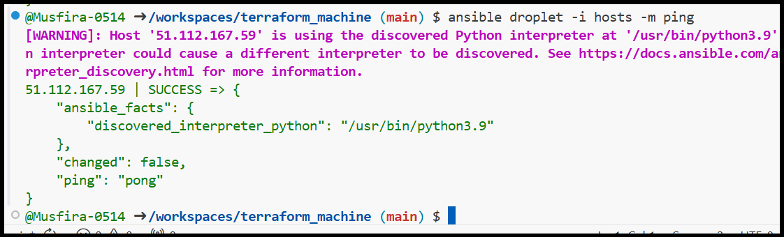

Ansible ping to all hosts

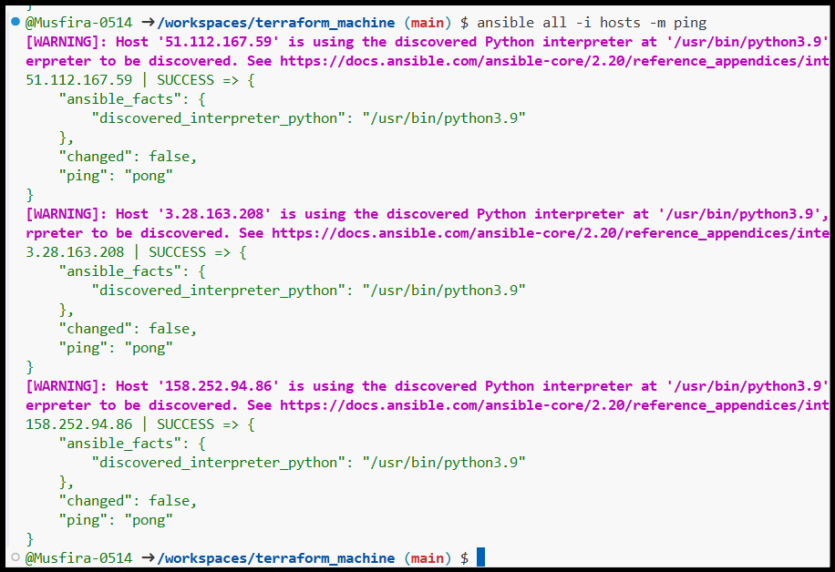

**Task 4 – Global Ansible Configuration & Nginx Deployment**

Global ansible.cfg configuration

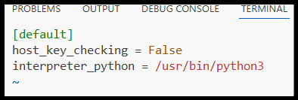

Hosts file without common SSH arguments

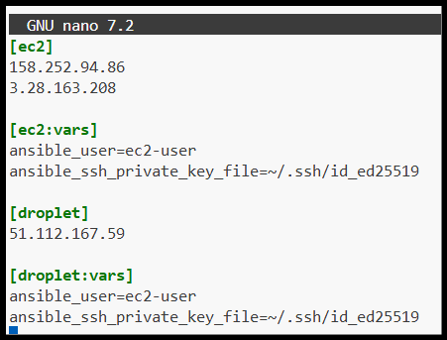

Successful Ansible ping using global config

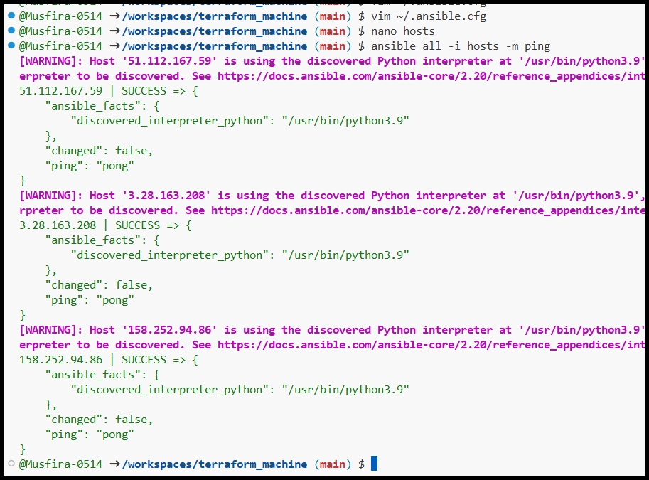

Ansible playbook creation

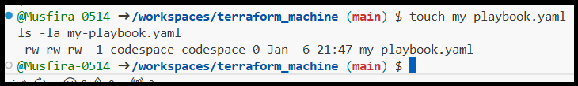

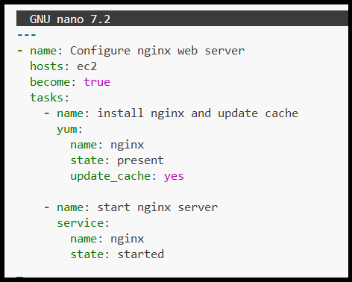

Nginx deployment playbook for EC2

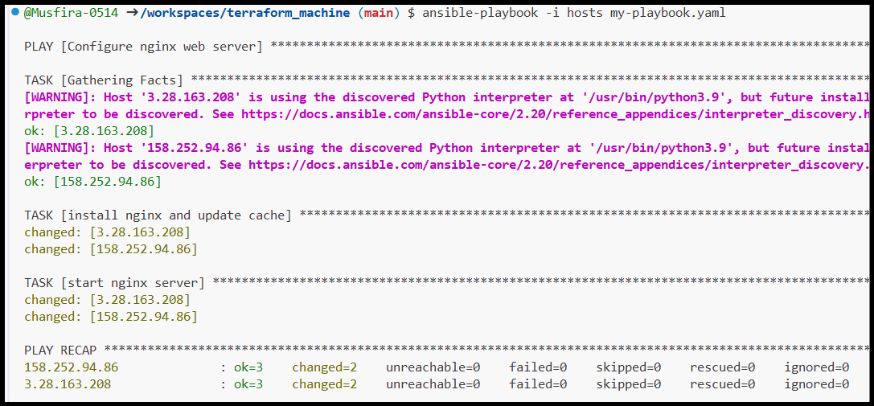

Successful playbook execution on EC2

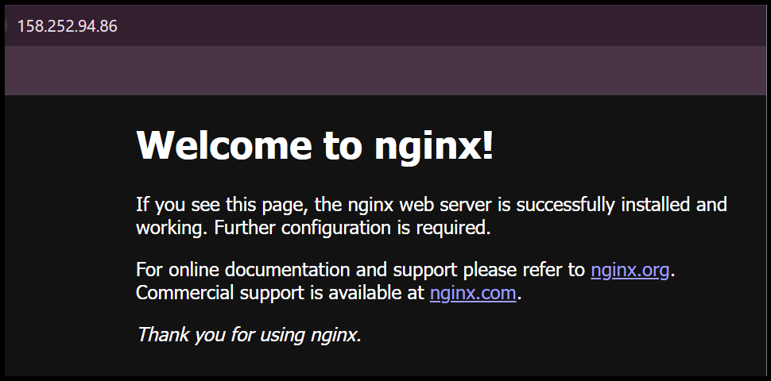

Nginx accessed via browser on EC2

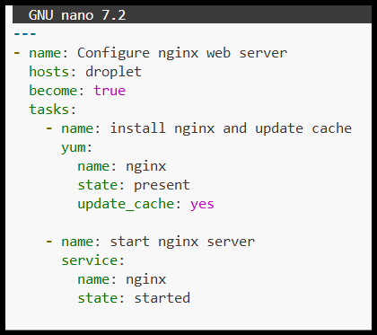

Nginx deployment playbook for droplet

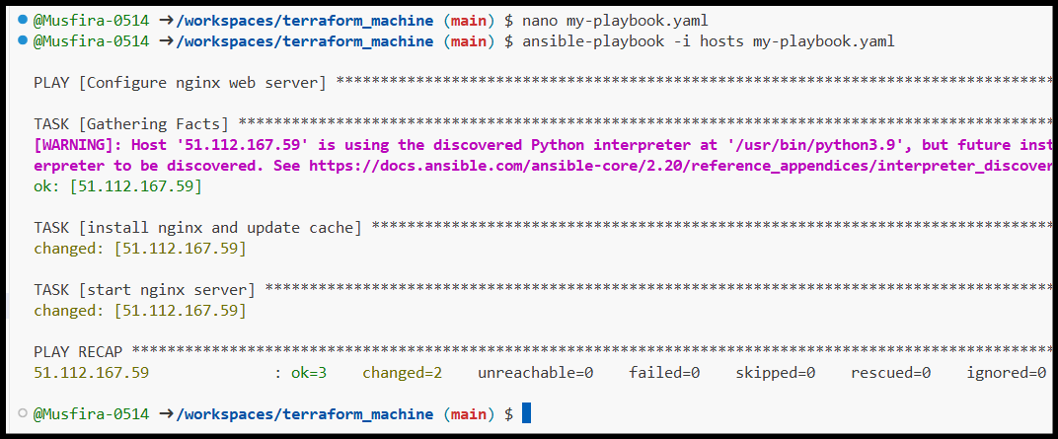

Nginx accessed via browser on droplet

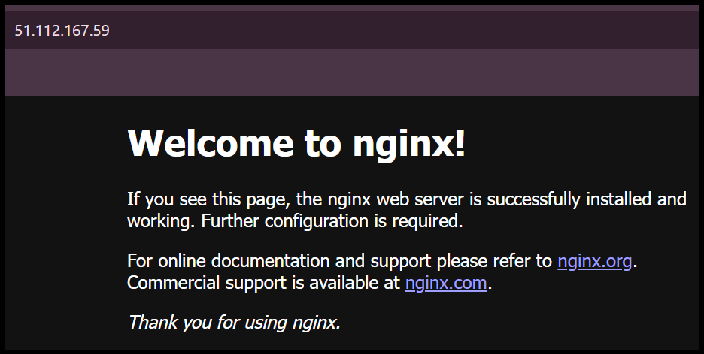

**Task 5 – Single Target Group & HTTPS Preparation**

Project-level ansible.cfg created

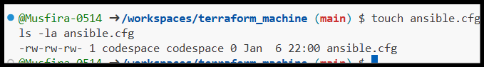

Project ansible.cfg configuration

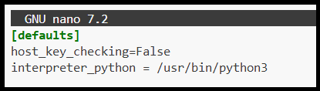

Terraform updated to single instance

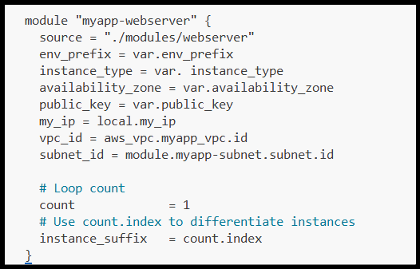

Terraform apply for single EC2 instance

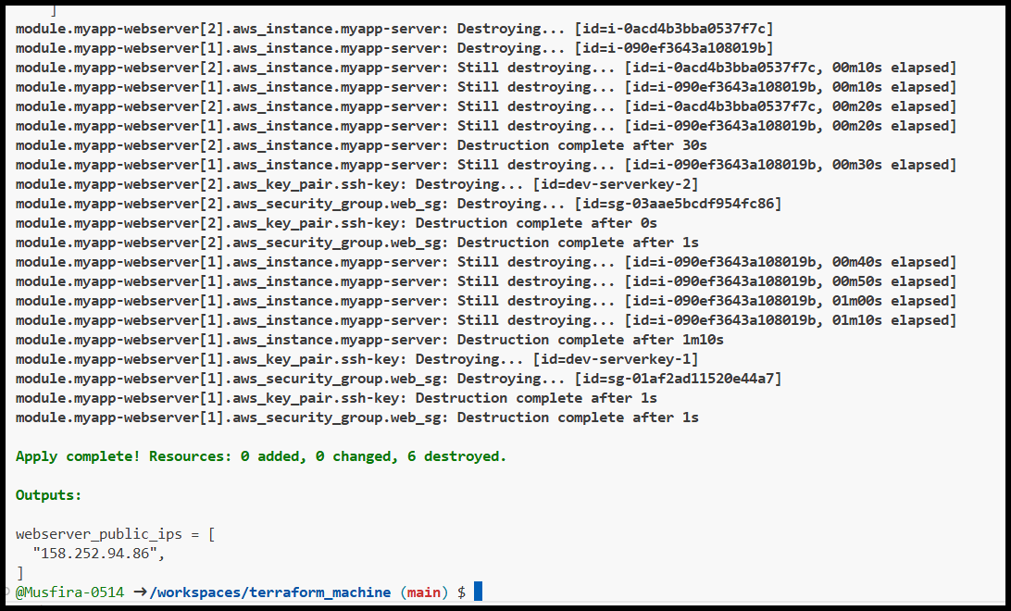

Terraform output showing single IP

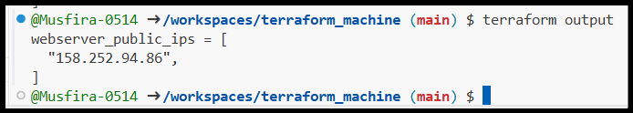

Inventory created for nginx group

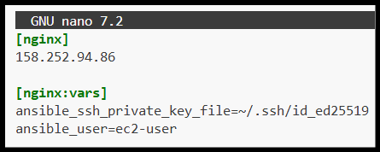

Playbook targeting nginx group

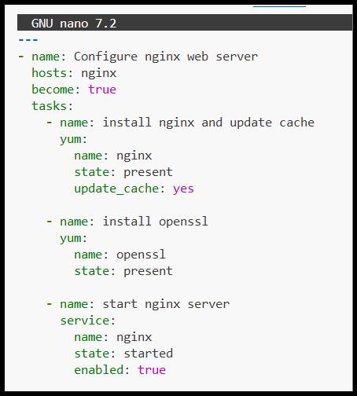

Successful playbook execution

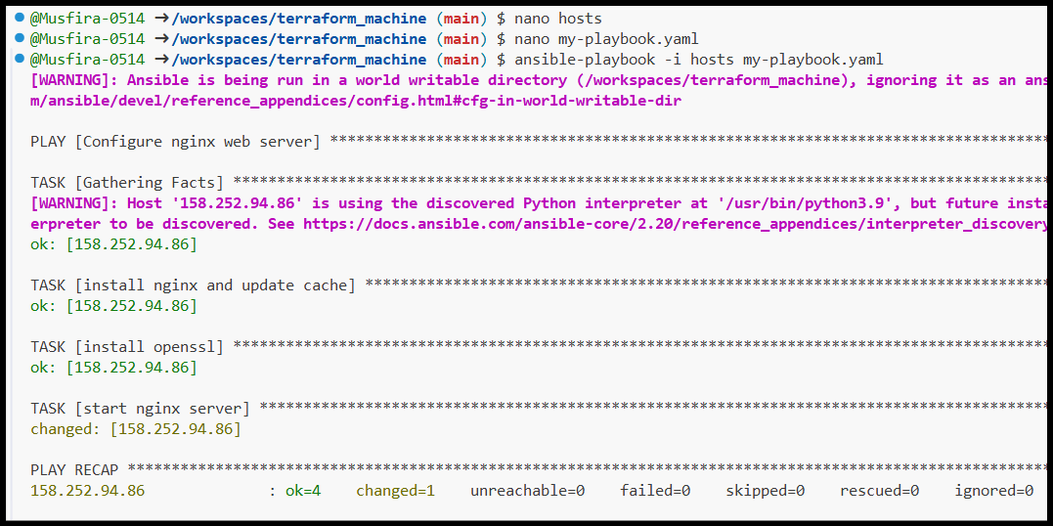

Nginx verified in browser

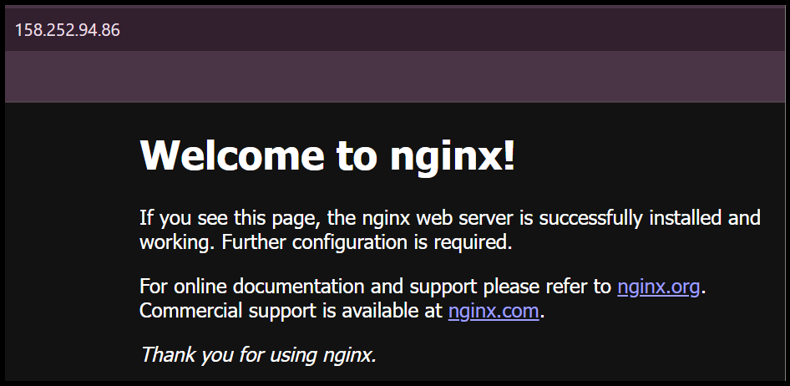

**Task 6 – SSL Certificate Automation**

SSL configuration added to Ansible playbook

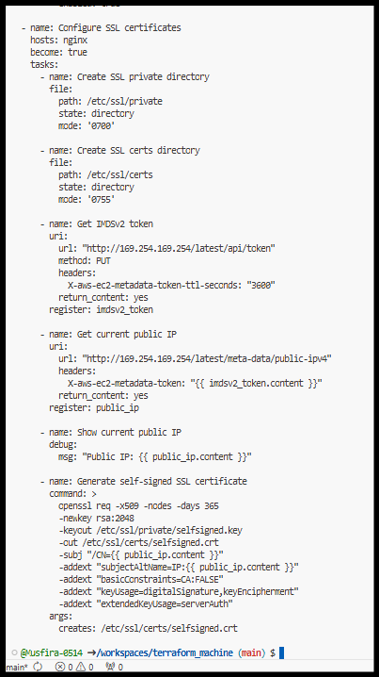

SSL playbook executed successfully

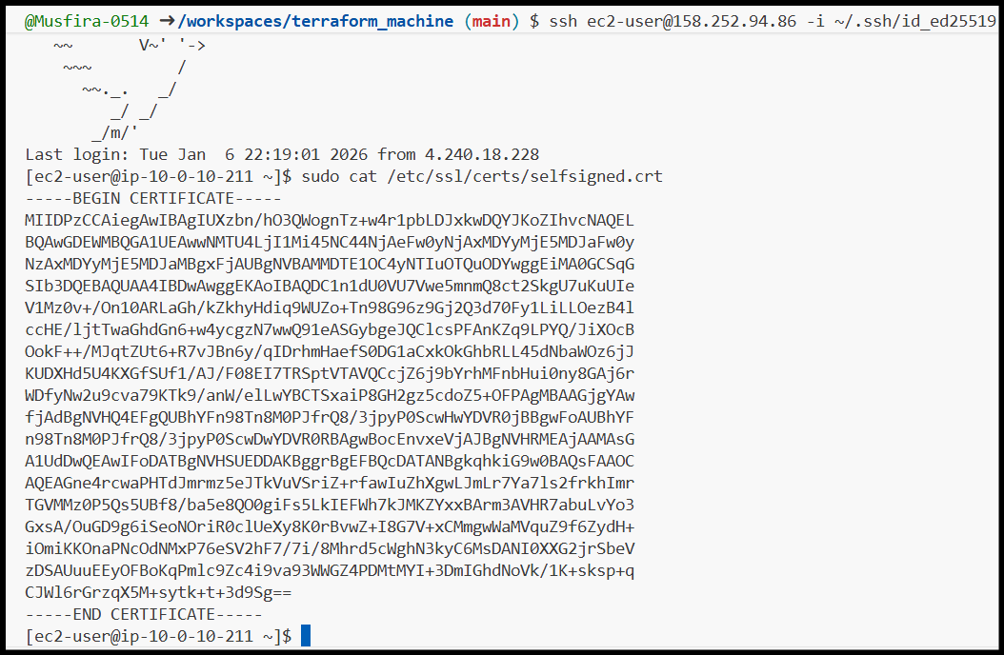

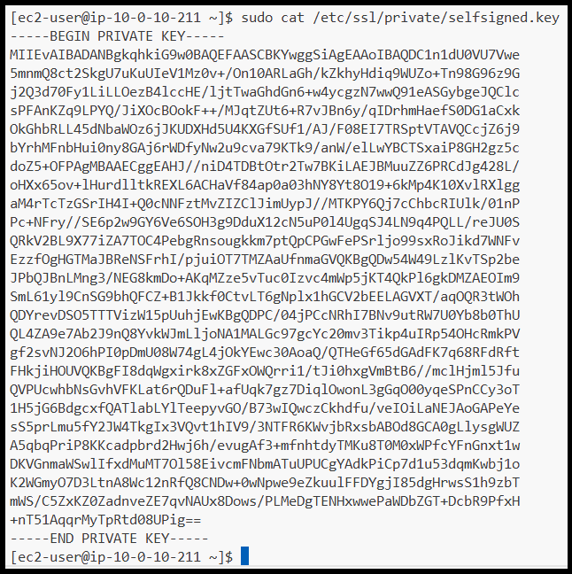

**Task 7 – PHP Frontend Deployment**

Files and templates directory created

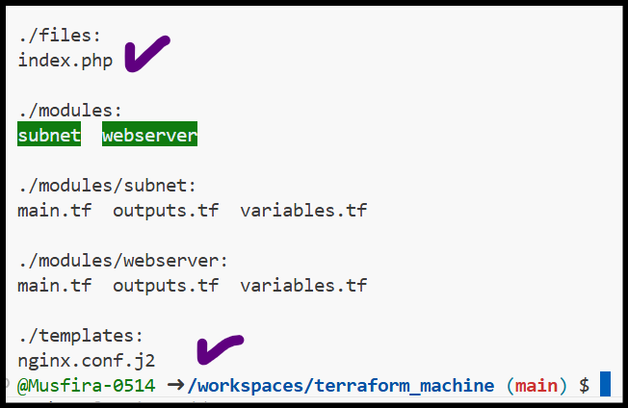

PHP index file content

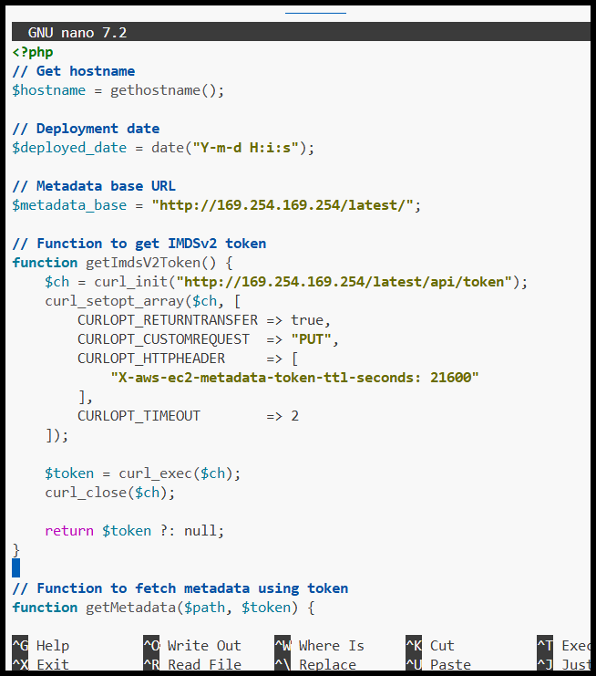

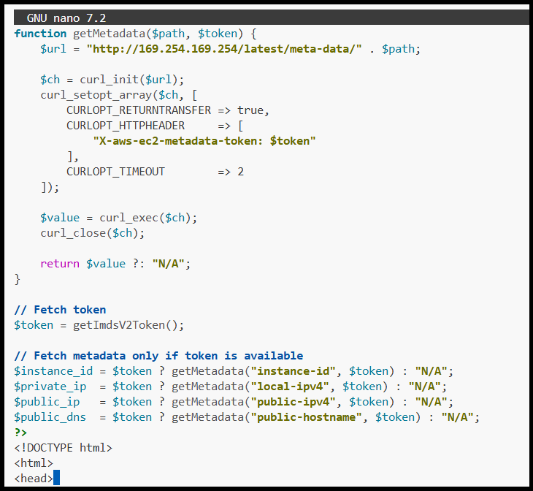

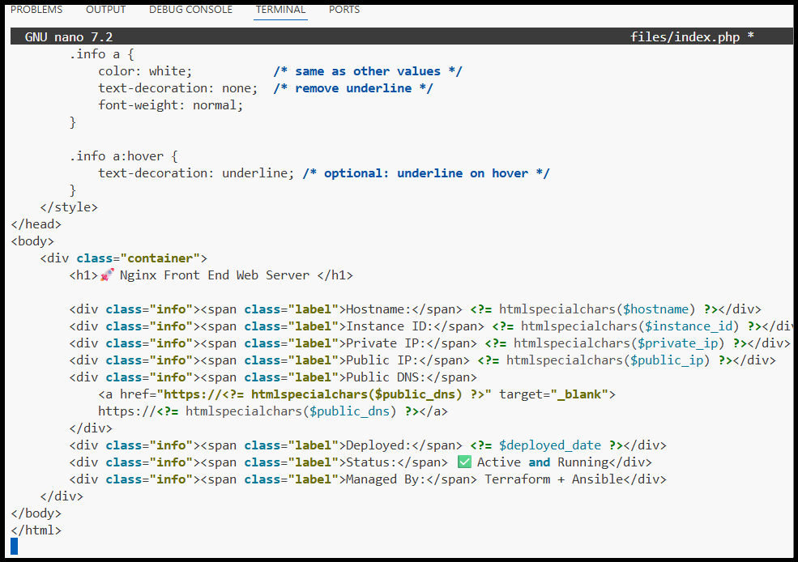

Nginx virtual host template for PHP

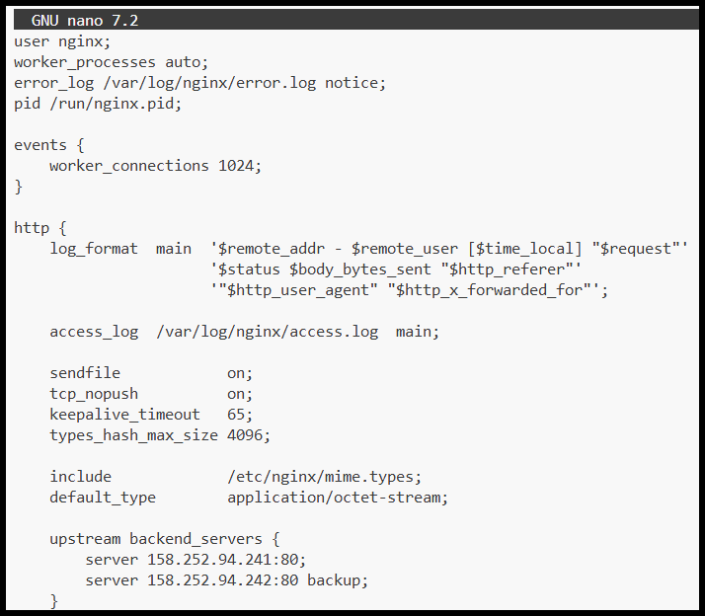

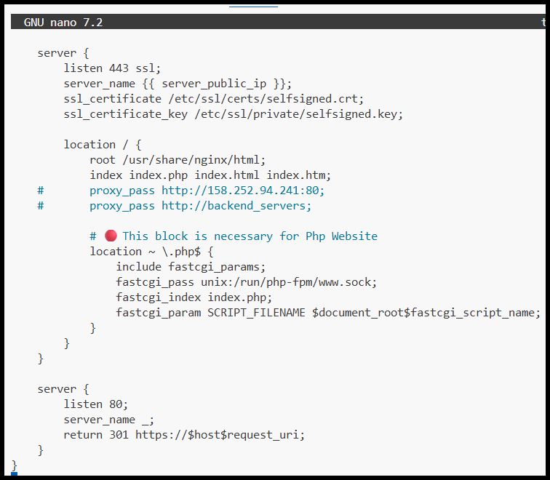

Web deployment playbook configuration

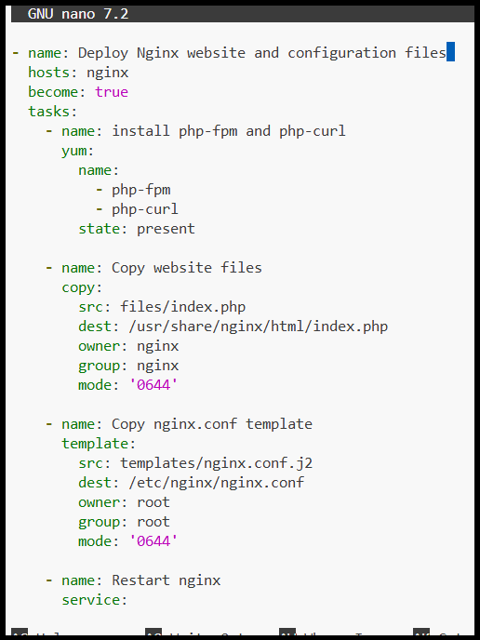

Successful PHP deployment via Ansible

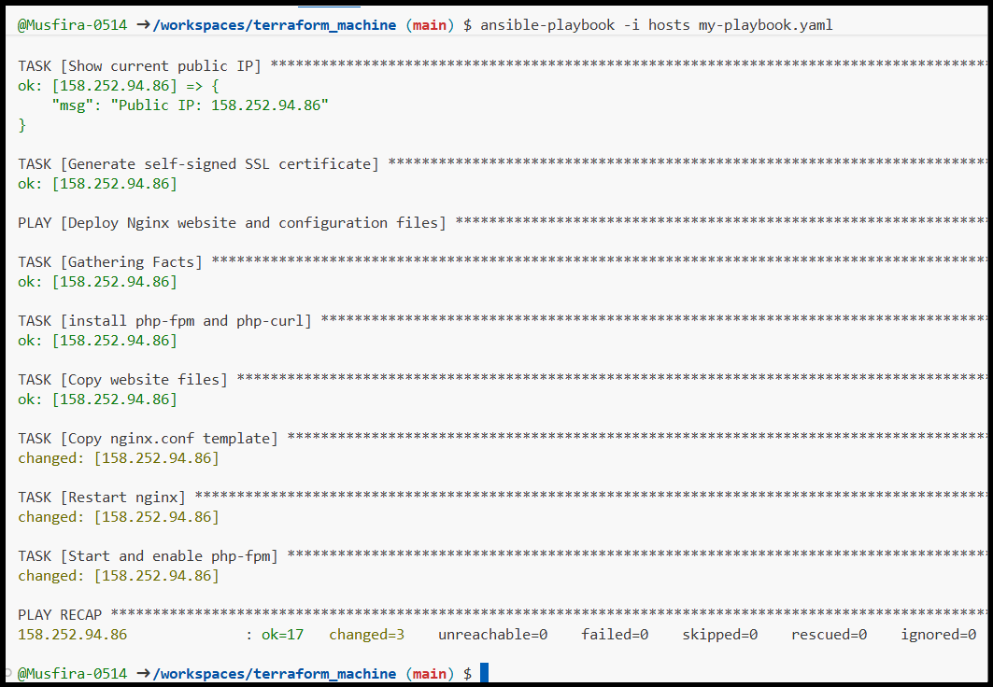

PHP application accessed over HTTPS

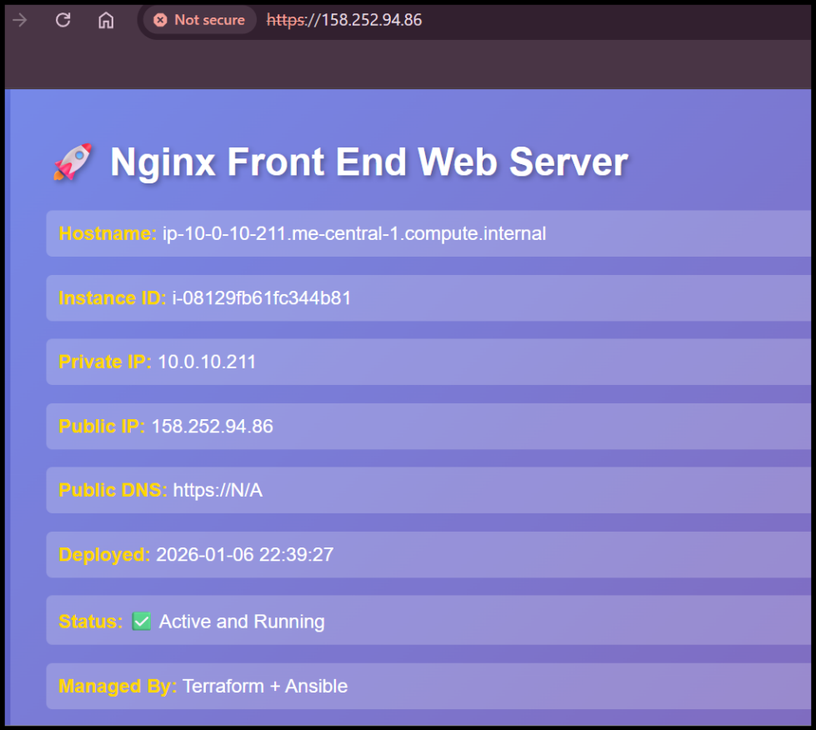

**Task 8 – Docker & Docker Compose Installation**

Previous infrastructure destroyed

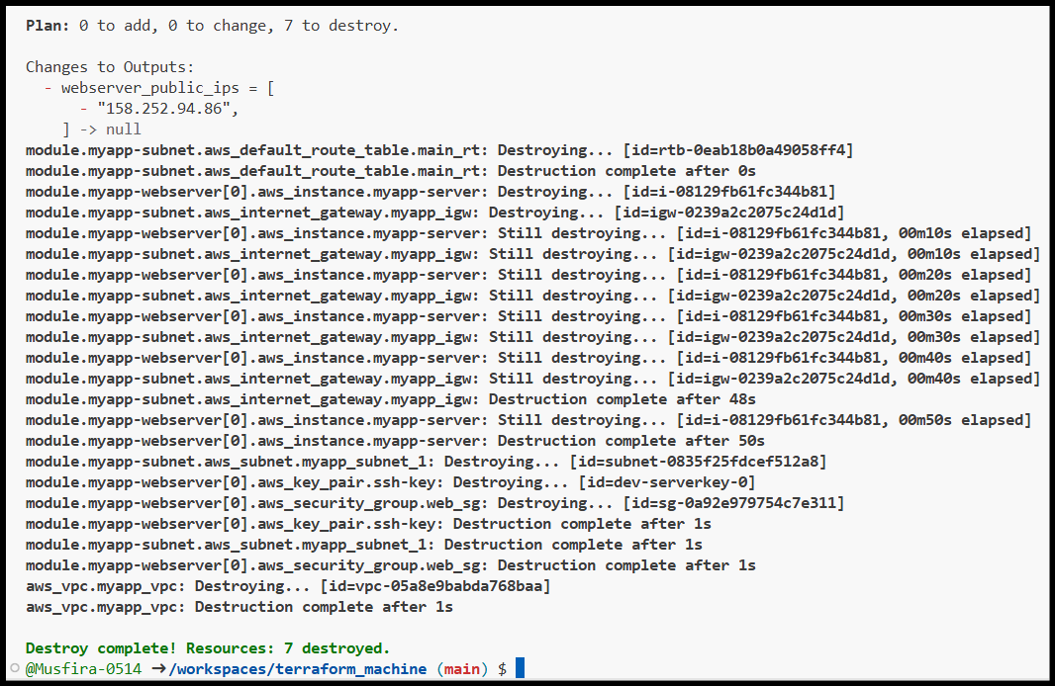

Terraform apply for Docker-enabled instance

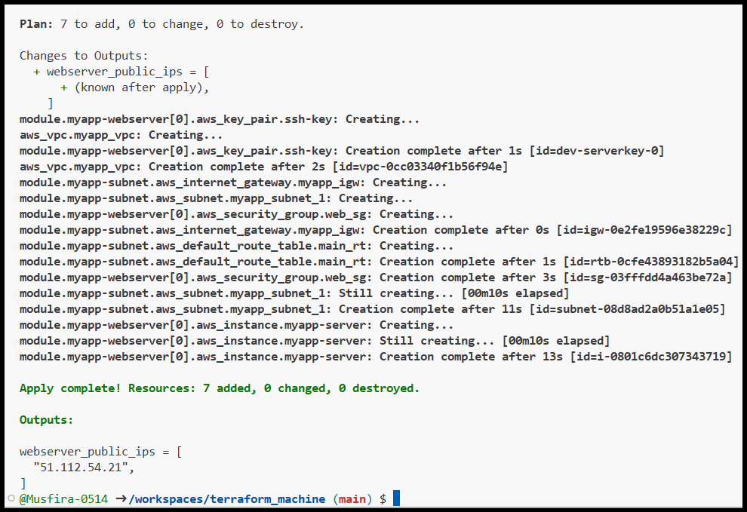

Terraform output showing new IP

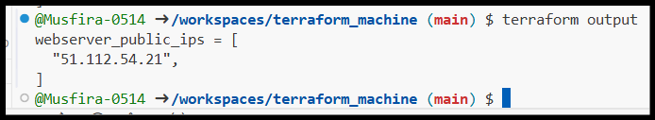

Inventory created for Docker servers

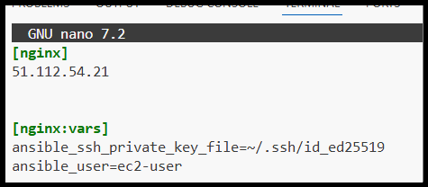

Docker installation playbook

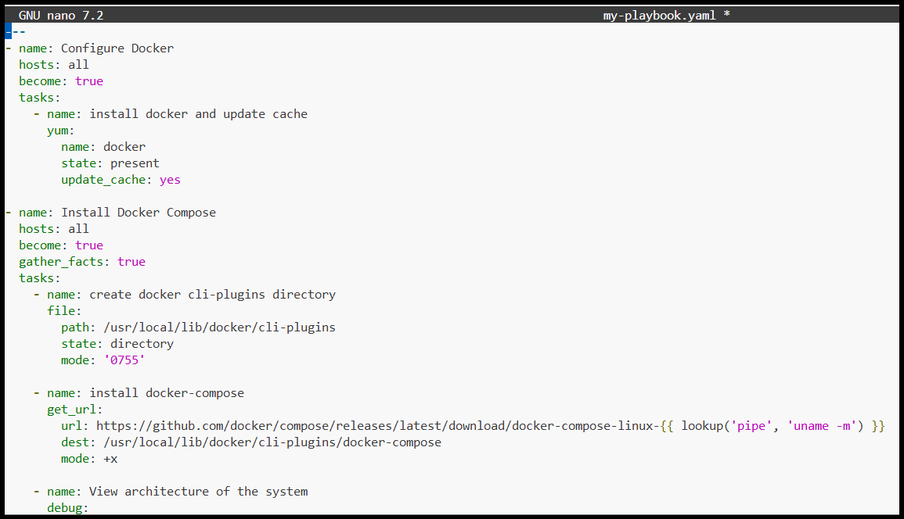

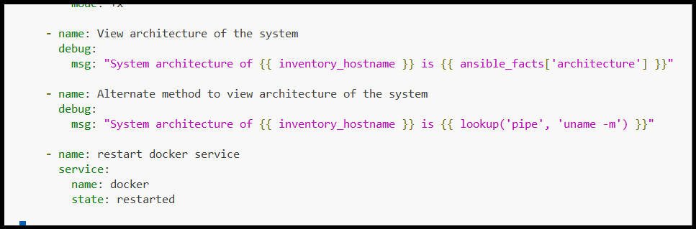

Successful Docker installation

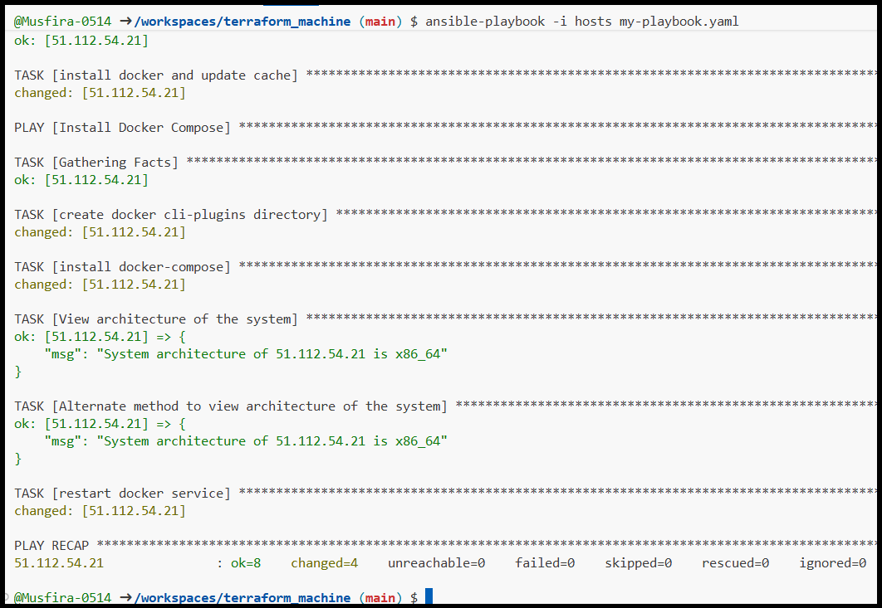

Docker containers verified on remote host

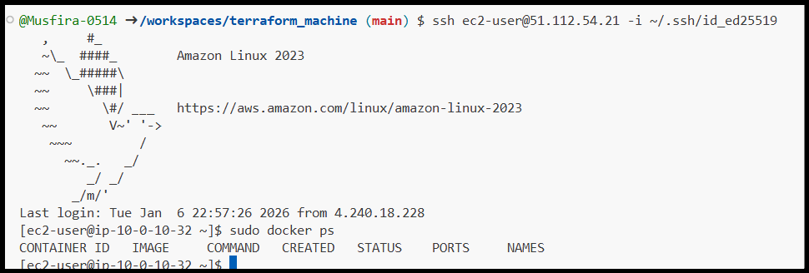

**Task 9 – Gitea Deployment with Docker Compose**

User added to Docker group via Ansible

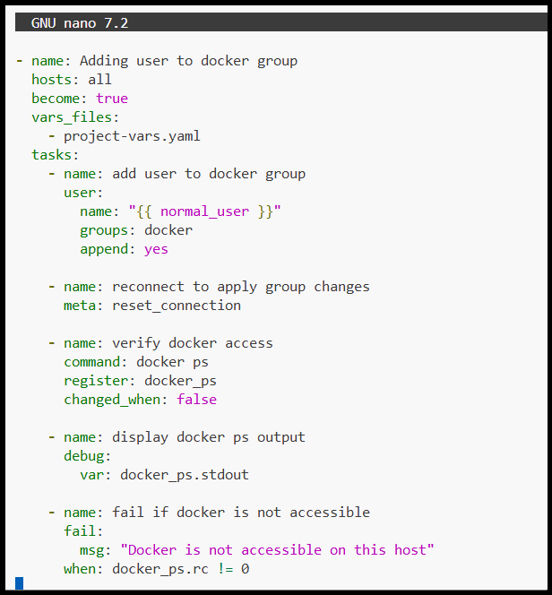

Project variables file configuration

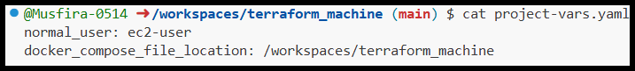

Docker Compose deployment playbook

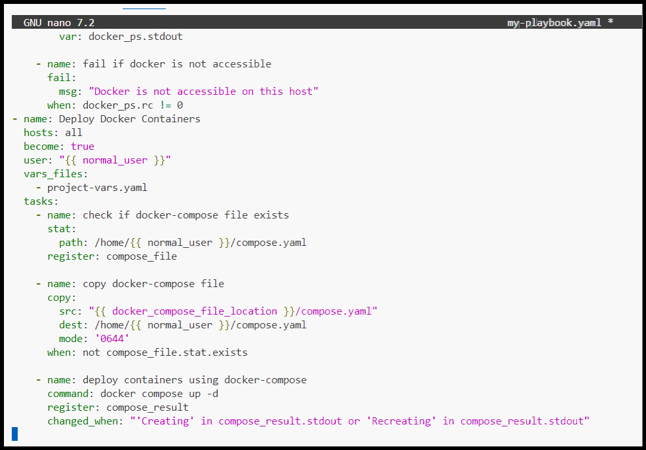

Docker Compose YAML file

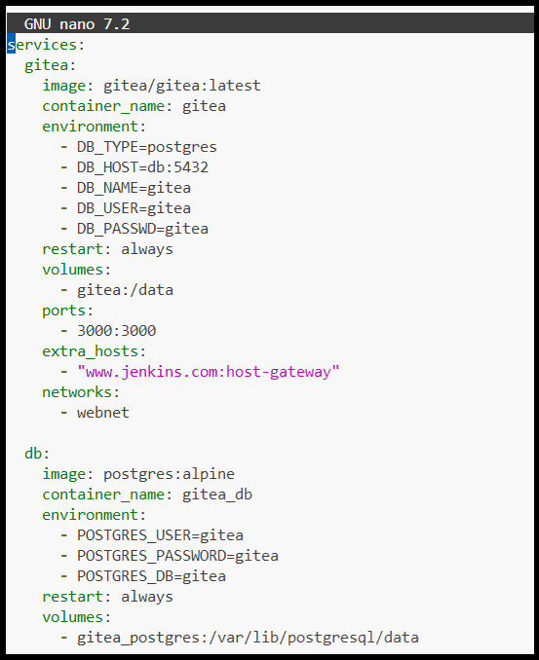

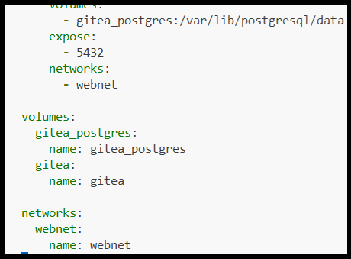

Successful Gitea deployment

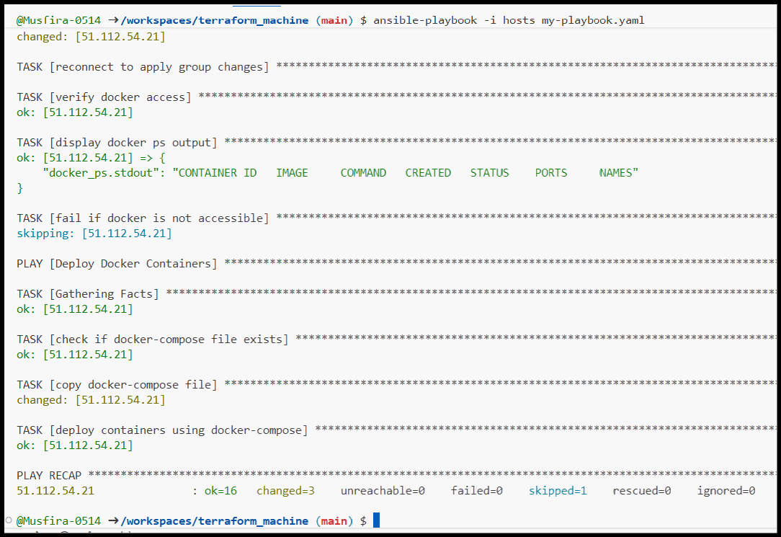

Security group updated for port 3000

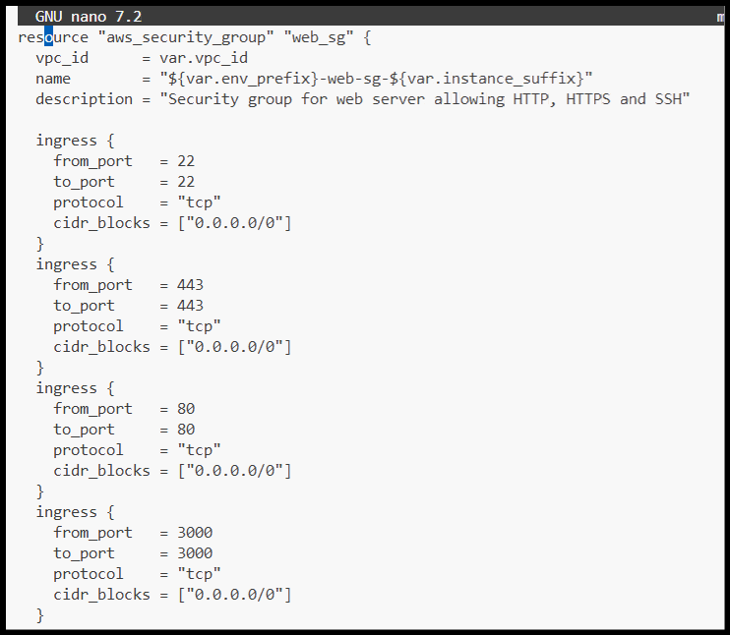

Terraform applied security group changes

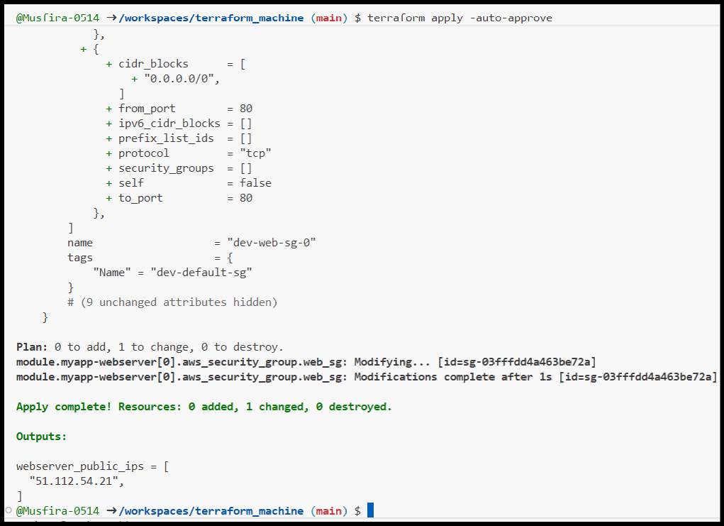

Gitea web interface accessed in browser

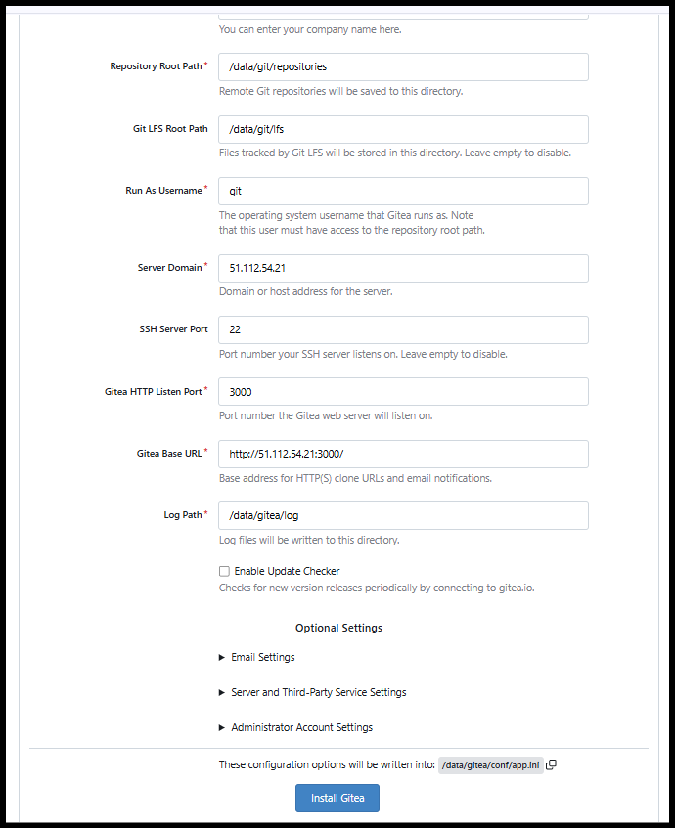

**Task 10 – Automating Ansible Using Terraform**

Terraform null_resource configuration

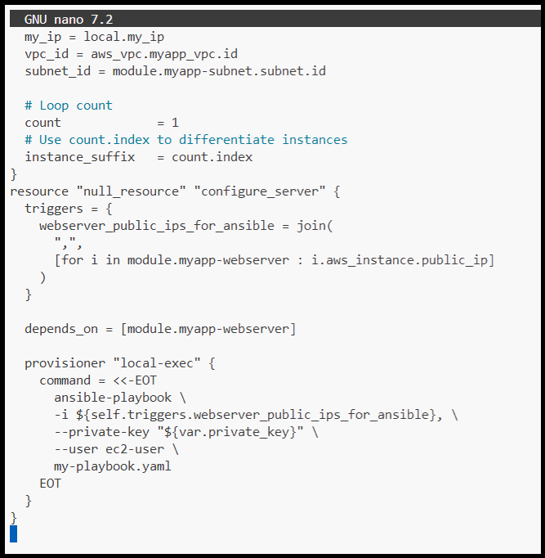

Terraform destroy before automation

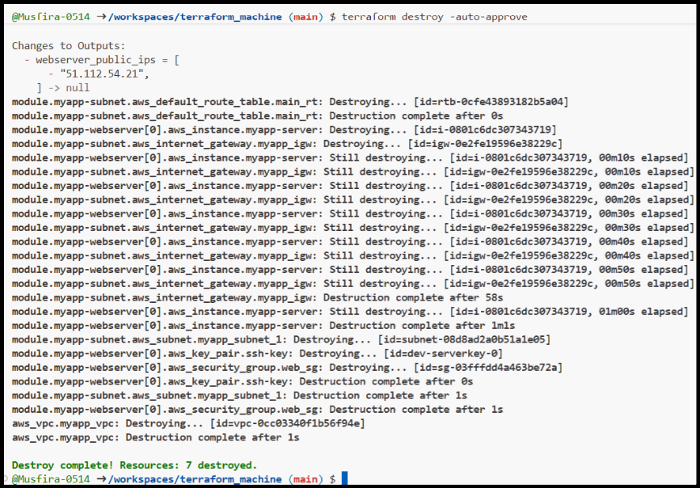

Terraform apply executing Ansible automatically

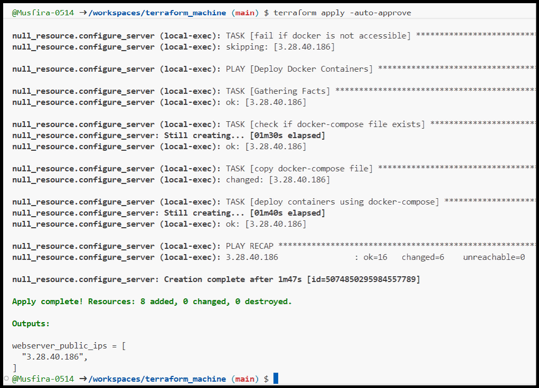

Ansible wait-for-SSH task

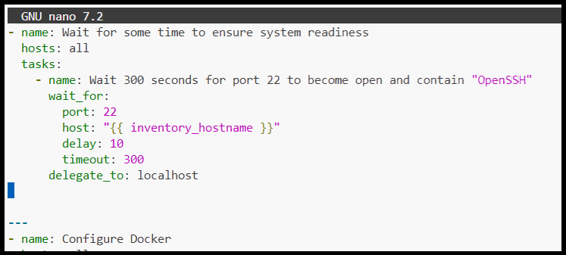

Successful Terraform apply after wait

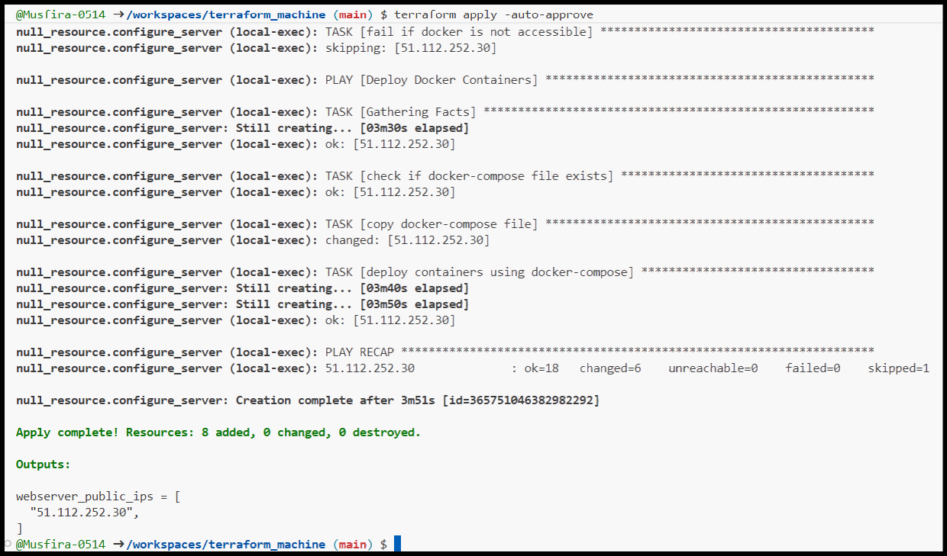

Application verified after automation

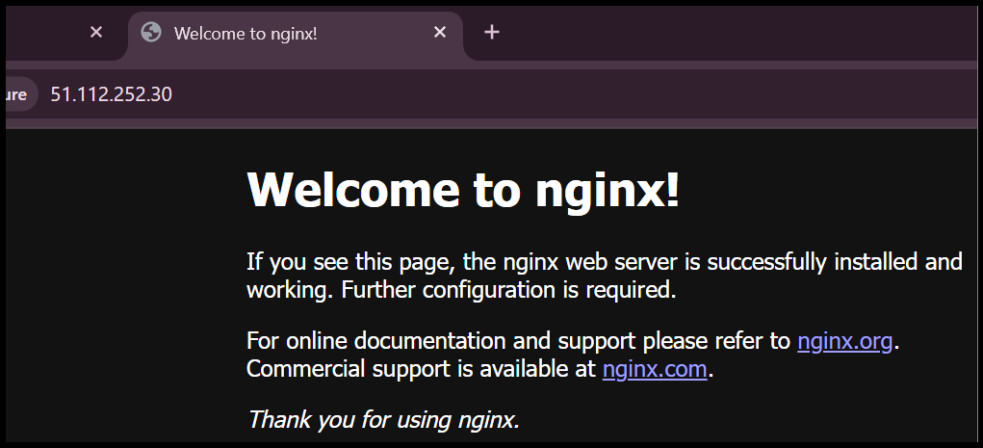

**Task 11 – Dynamic Inventory Using aws_ec2 Plugin**

Ansible configuration for aws_ec2 plugin

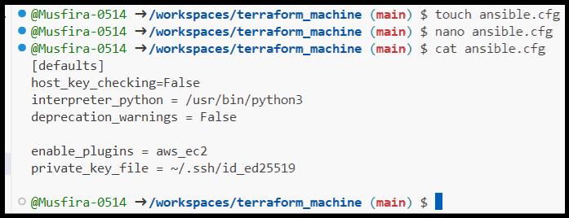

Dynamic inventory file creation

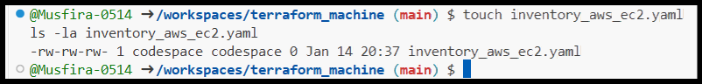

Initial dynamic inventory configuration

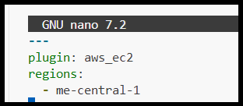

Terraform modules for dev and prod

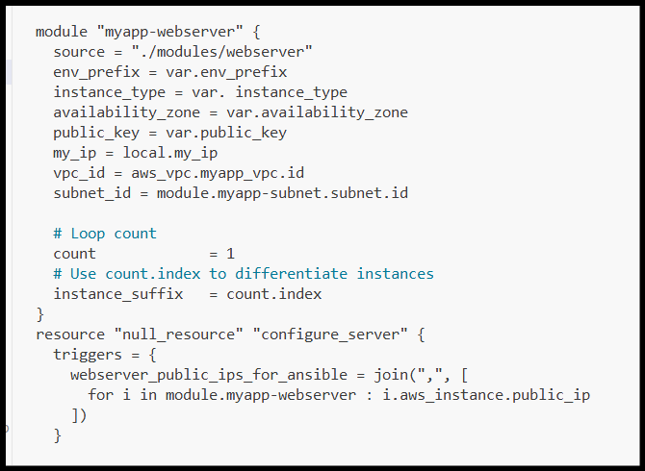

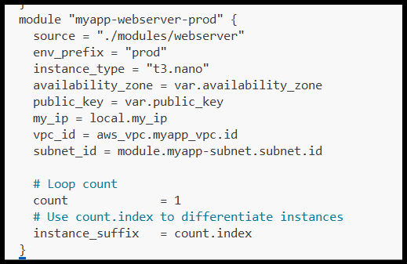

Outputs file showing dev and prod IPs

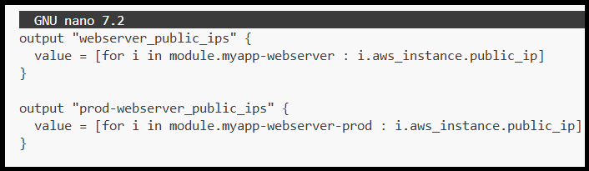

Terraform output of dynamic instances

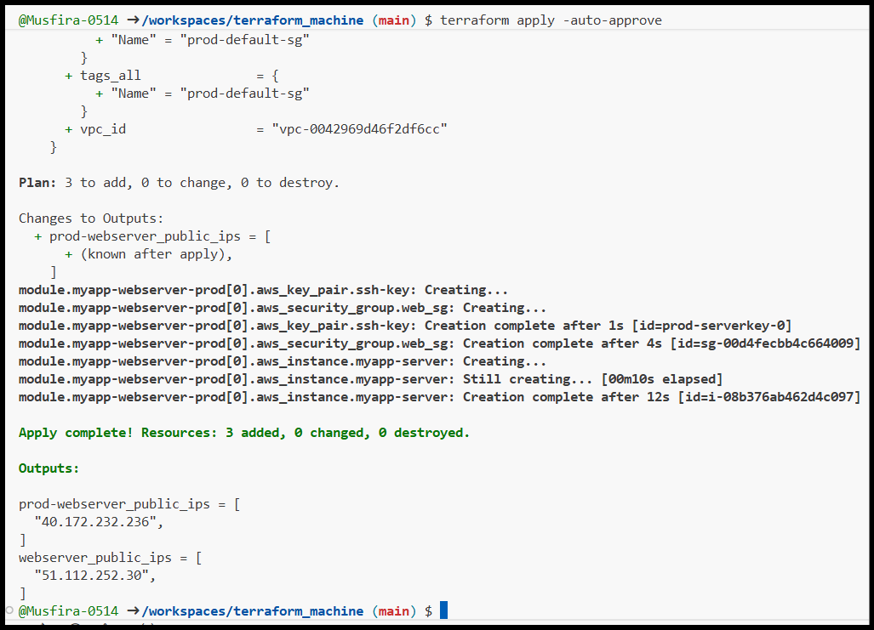

Boto library installation

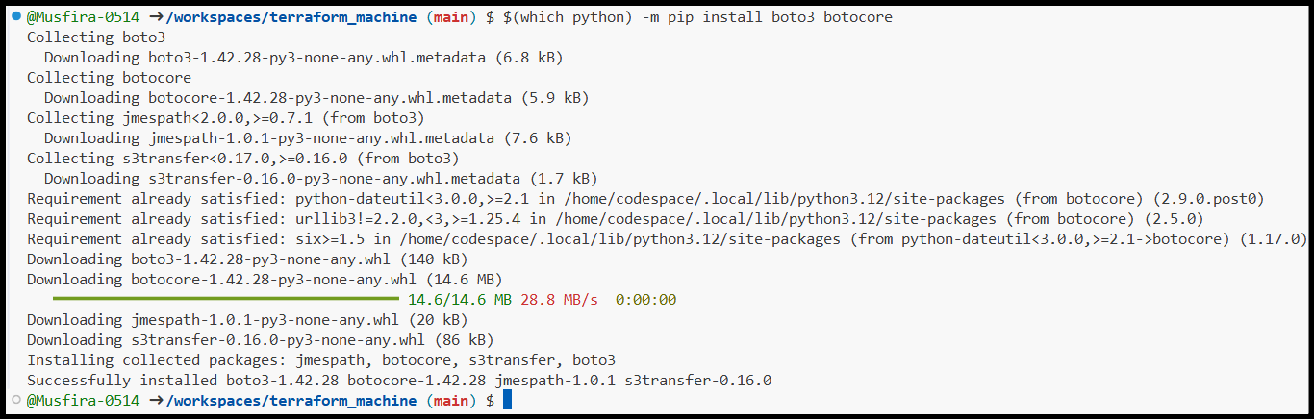

Boto version verification



Dynamic inventory graph output

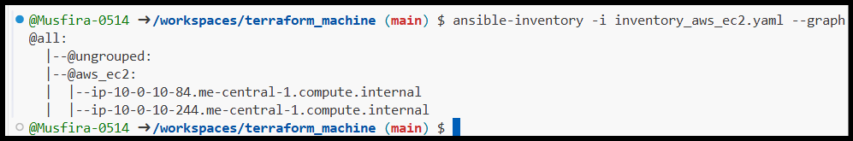

**Task 12 – Inventory Filtering & Grouping**

Dynamic inventory grouped by tags

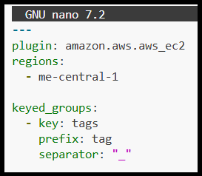

Inventory graph showing tag-based groups

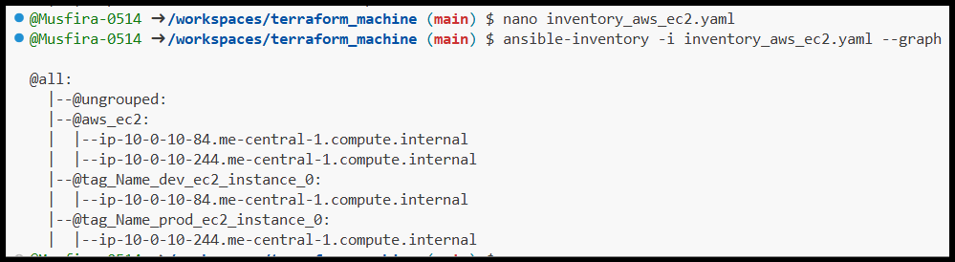

Inventory grouped by instance type

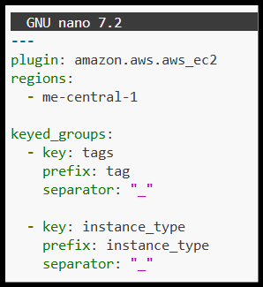

Full inventory graph view

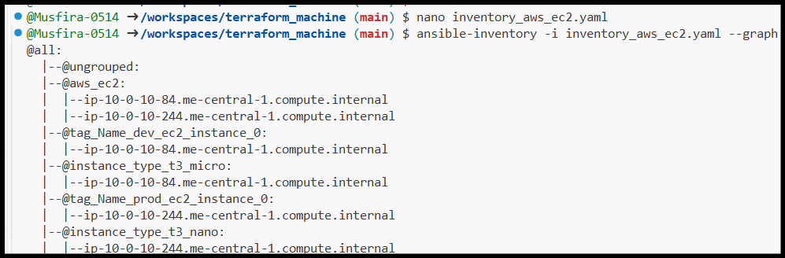

Playbook execution on all hosts

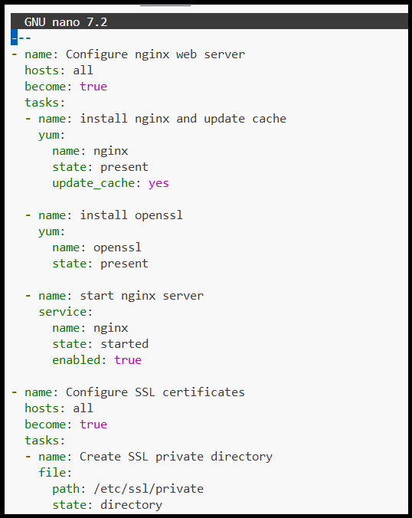

Playbook execution on dev hosts

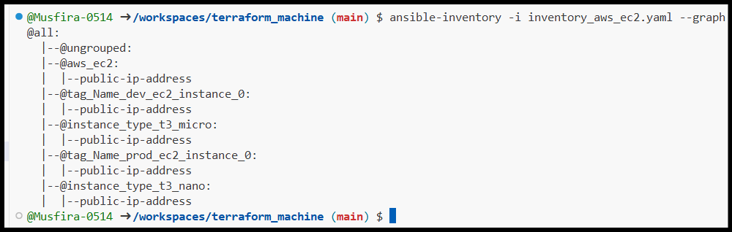

Playbook execution on prod hosts

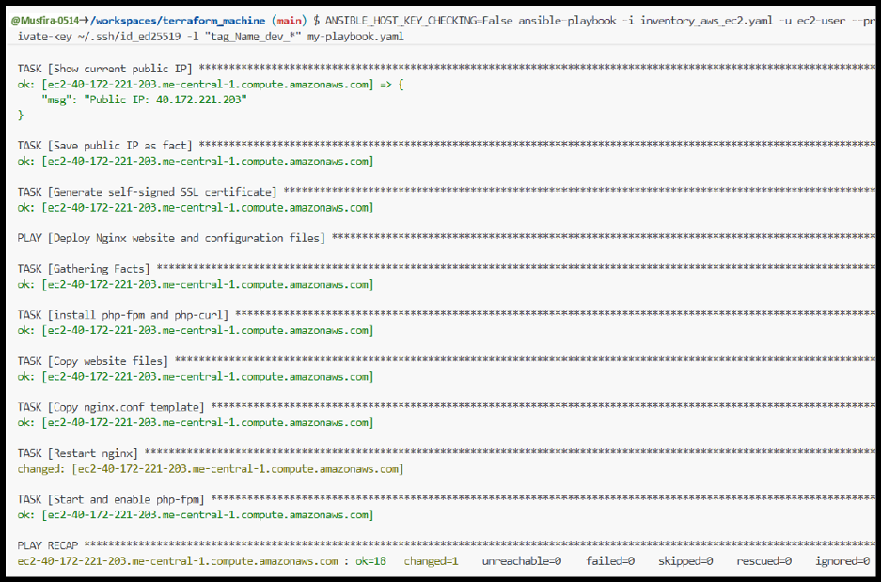

Playbook execution on t3.micro instances

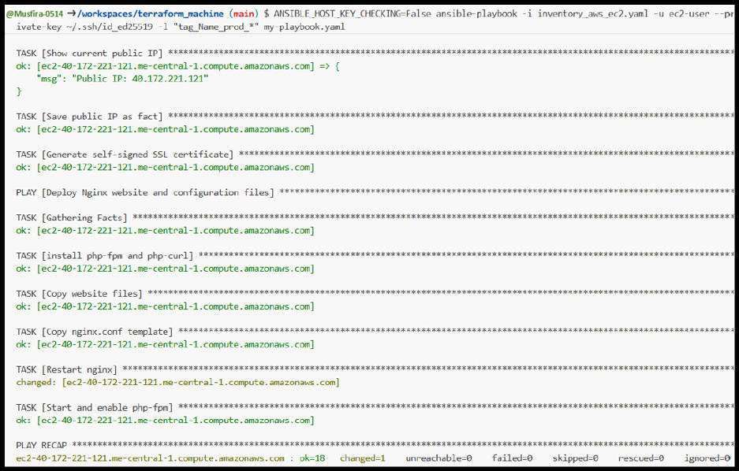

Playbook execution on t3.nano instances

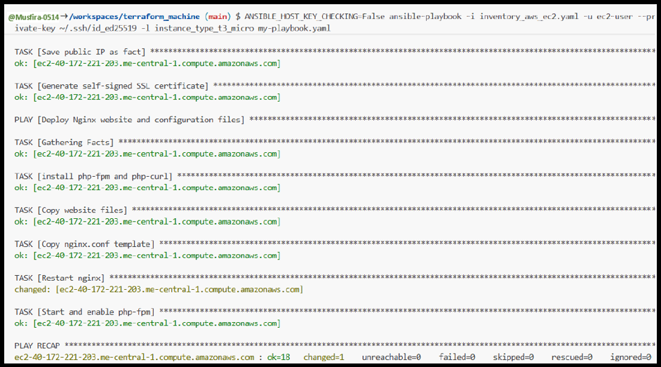

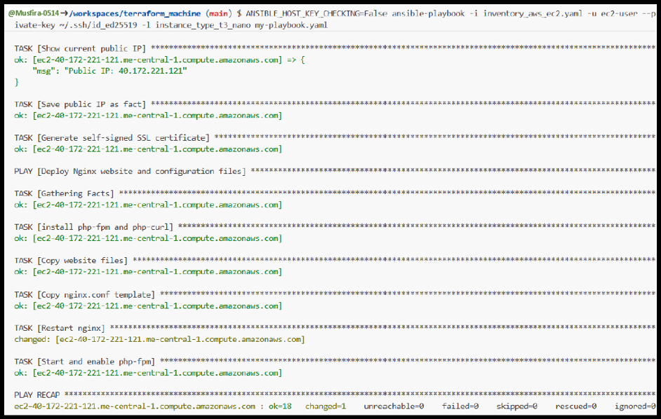

Default inventory configured in ansible.cfg

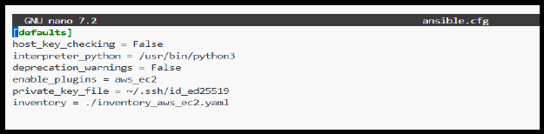

Playbook execution without specifying inventory

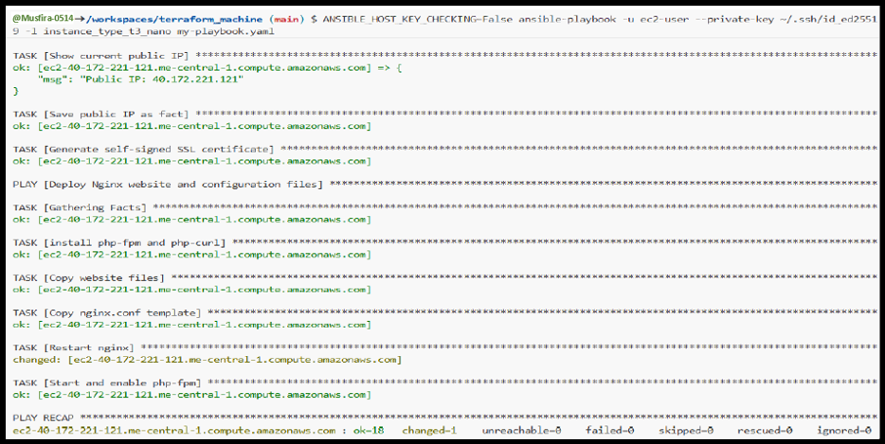

**Task 13 – Ansible Roles Implementation**

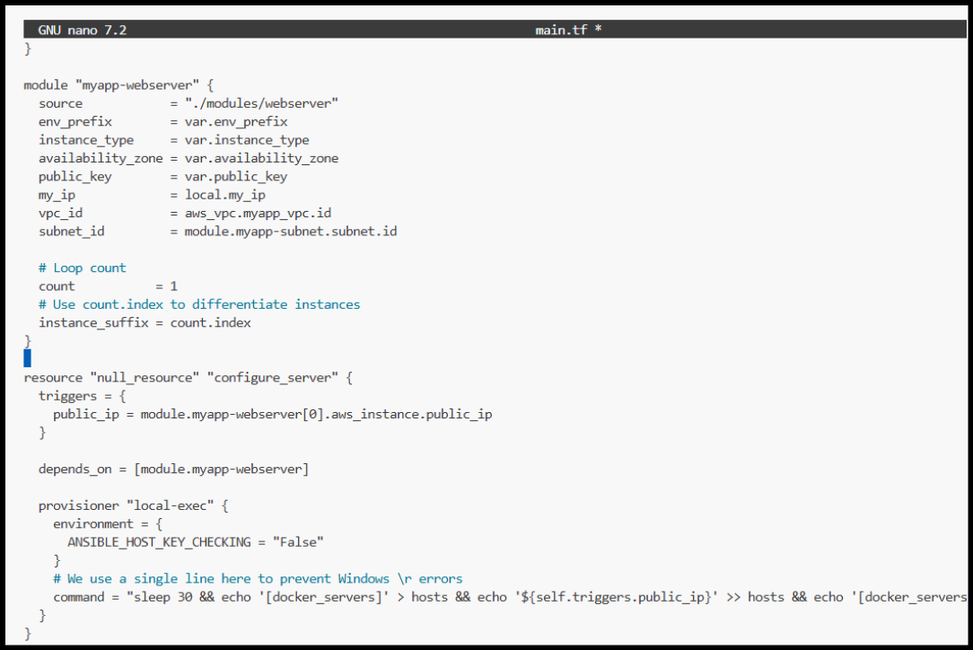

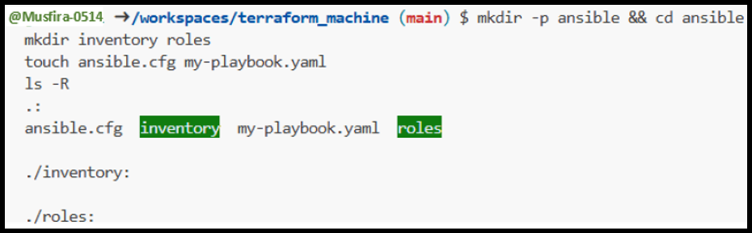

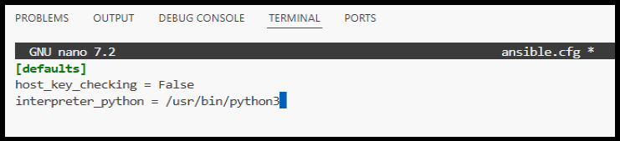

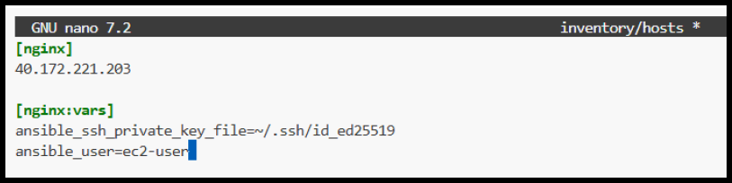

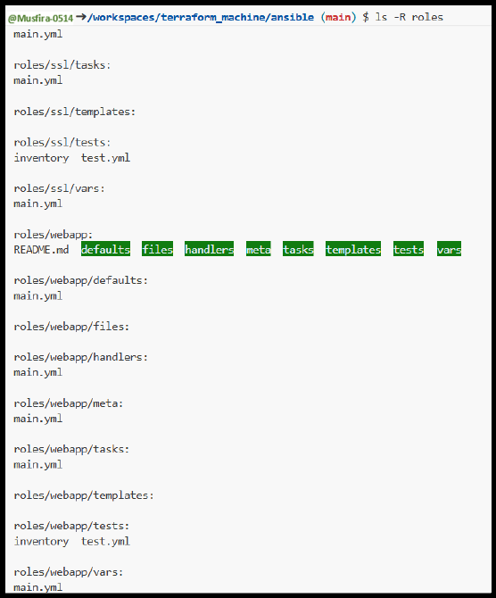

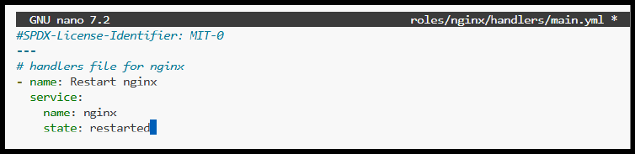

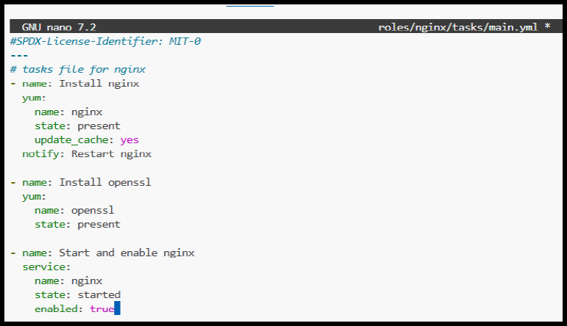

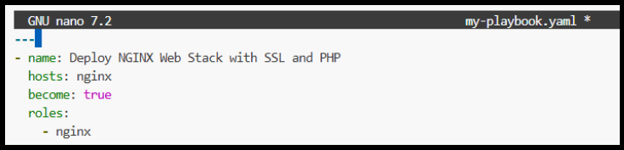

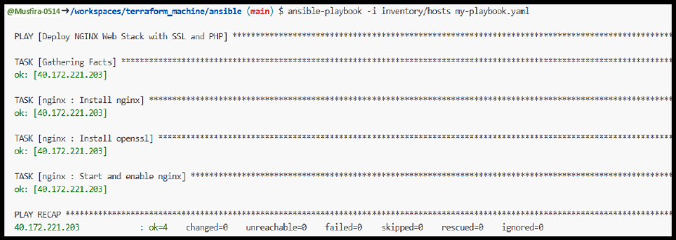

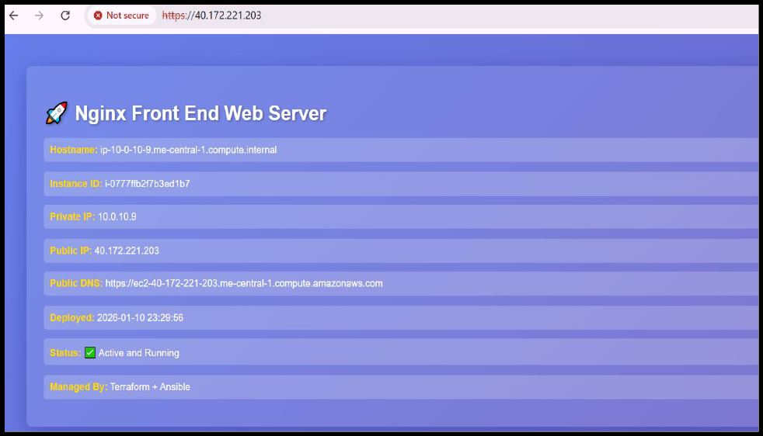

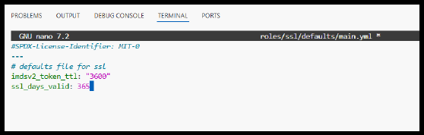

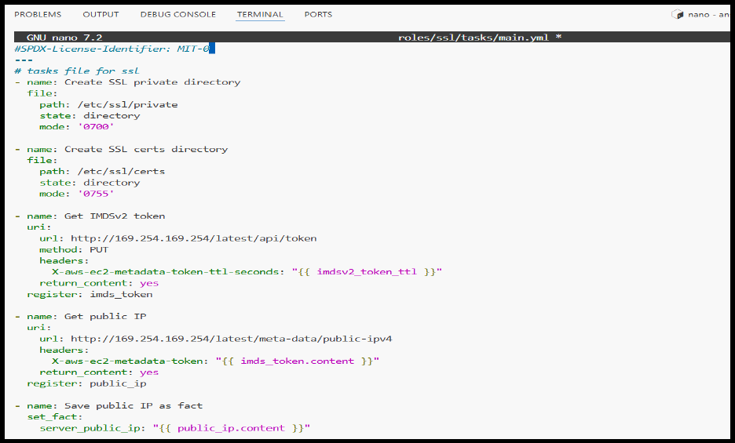

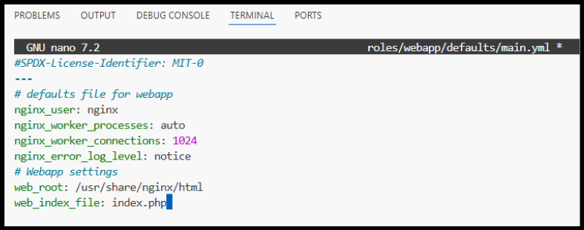

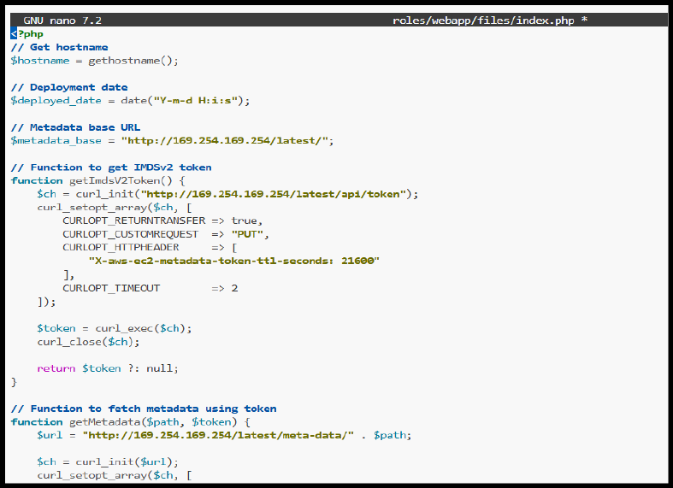

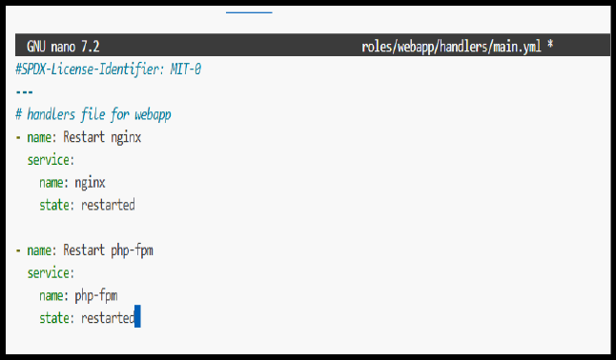

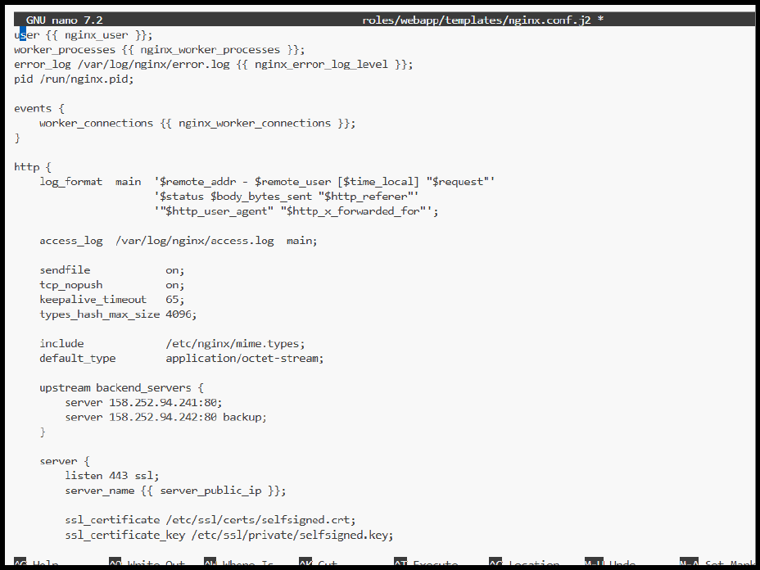

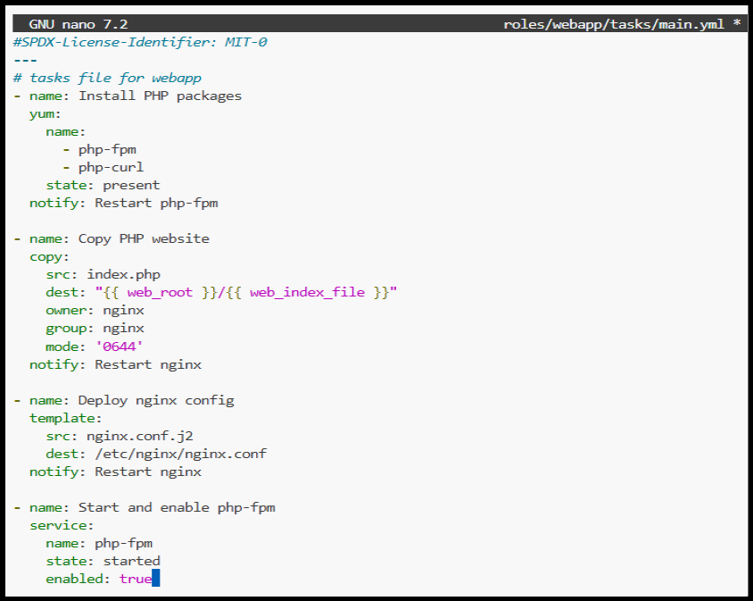

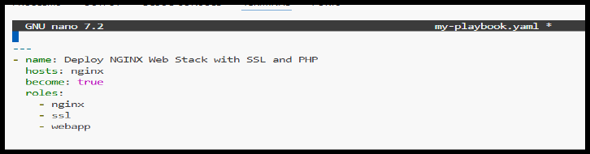

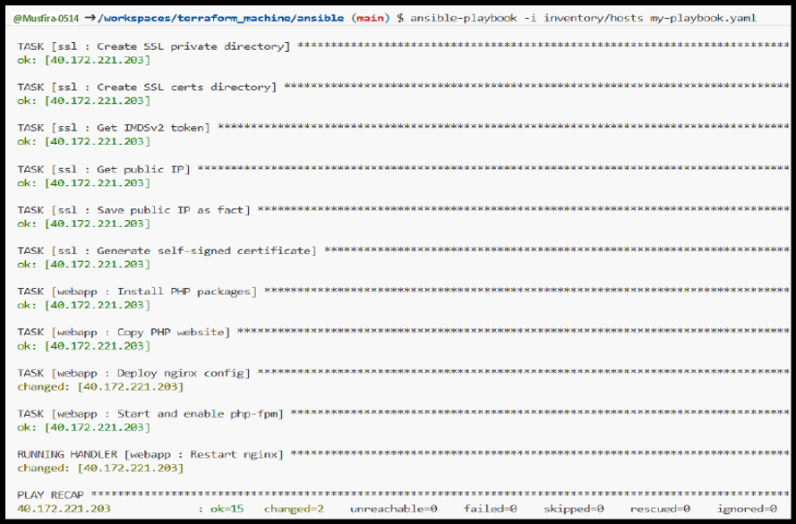

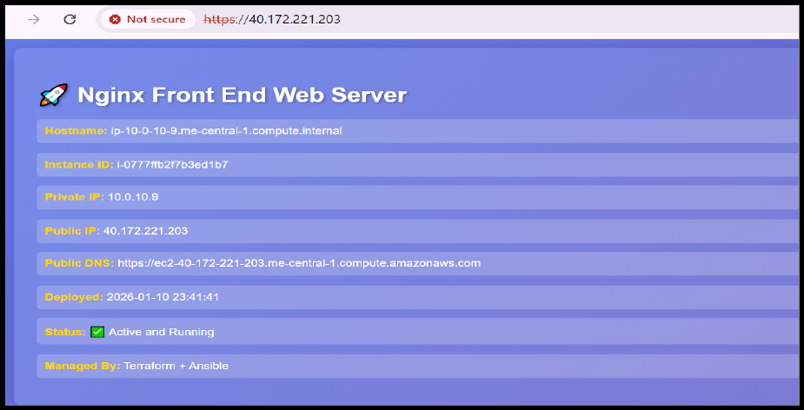

**Cleanup**

cleanup_terraform_destroy

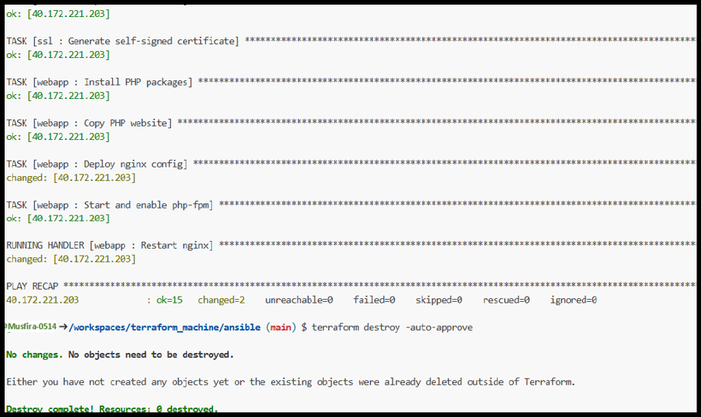

cleanup_tfstate

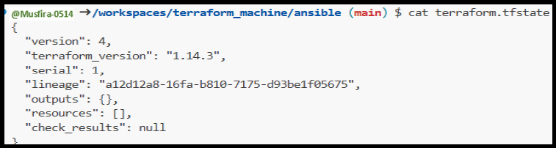

cleanup_aws_console

